FY2026
FC 0310 – McKinney-Vento Homeless Education Grant (competitive)

Questions and Answers

Please email questions to achievement@mass.gov with the
Subject Line: FY2026 FC 0310 Question

Questions and responses will be posted here and updated periodically until the grant due date.

Table of Contents
Important information 1
Questions through May 16, 2025 2
Questions through May 23, 2025 2
Questions through May 30, 2025 3
Questions through June 6, 2025 4
Questions through June 12, 2025 4

Important information
Accessing the application in GEM$: All eligible entities have access to the application in GEM$. In order to begin an application, the entity’s User Access Administrator must assign the role of LEA FC 0310 McKinney Vento Homeless Education Grant (Federal/COMP) Grant writer.
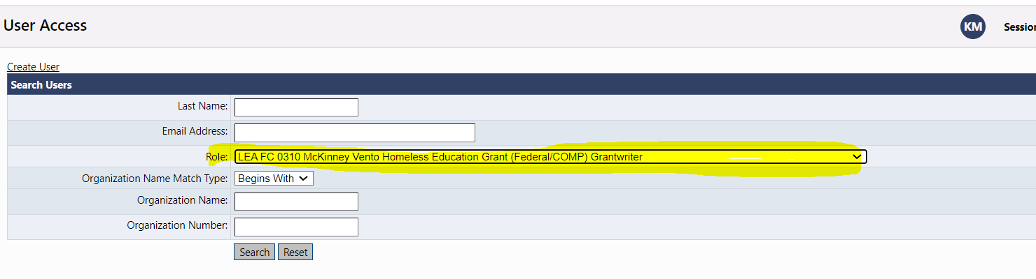
For first-time GEM$ users, see the GEM$ Submission Instructions section in the RFP (https://www.doe.mass.edu/grants/2026/0310/) for additional information about how to access GEM$ and submit an application.

Questions through May 16, 2025
- Does the total # of enrolled students include both homeless and foster care or just homeless?
The total number of enrolled students in the FC310 McKinney Vento Homeless Education competitive grant application is for homeless students.

- When do you think this grant will be posted in GEMS?
The grant application for FC310 is available in GEM$. For details on how to access GEM$, please refer to the important information section above.

- I noticed that the McKinney Vento grant posted yesterday, however it is not available in GEM$ for FY26. Will it take a few days for it be able to view in GEM$?
The grant application for FC310 is available in GEM$. For details on how to access GEM$, please refer to the important information section above.

- Where can I find the applicant criteria and job description for the regional Liaison TA Specialist?
The applicant criteria and the job description of the Regional Technical Assistance Specialist can be found in the GEM$ FC310 grant application related document section.

Questions through May 23, 2025

- Is it required to have either: a) district Homeless Education Program Services Coordination Committee, b) or have an established local committee/council?
In order to be eligible and apply for this grant under Category B (Homeless Migrant student Support) as a district that enrolls more than 40 Homeless Migrant Students? If we apply only under category B, are we exempt from the above requirements; or would we have to create either of those committees/councils as a condition of being awarded a grant?
Please refer to our FC310 grant RFP Key Grant Requirement about Homeless Education Service Coordination Committee: Agrees to convene a local Homeless Education Service Coordination Committee or actively participate in an established local committee/council designed to assess the needs and assist in the provision of services to the homeless student population in the district if receiving funds for Support Services, Family and Community Engagement, Unaccompanied Homeless Youth, and Homeless Migrant Student Support (sub-category A, B, C & D);

To apply for Category B - Homeless Migrant Student Support, please refer to the definition of migrant students under MMEP and FC310 grant RFP’s funding eligibility to determine if your district is eligible to apply.

- Are we allowed to use the FC310 McKinney-Vento Grant to support a portion of the salary for case manager at XXXXXXX(ABCDEFG), our local agency partner. This would be to continue case management and coordination services through our XXXX Public Schools Homelessness Initiative.
The McKinney-Vento Homeless Assistance Act prioritizes funds to support the education of students who are homeless through racially equitable and culturally responsive high-quality programming in any or all the following…..
- collaborating with external agencies to provide students, families and caregivers who are homeless with medical, dental, mental health, and other community and state services;

- Where do we find the count of migrant students for our district?
Districts should identify the number of migrant students in their enrollment systems by implementing a migrant screening process. The Massachusetts Migrant Education Program (MMEP), a vendor of DESE, also identifies migrant students in various communities across the Commonwealth.

Questions through May 30, 2025

- If there was a template for the required MOU for district planning to apply for the Homeless Migrant Support.
Districts should create a customized Memorandum of Understanding (MOU) document that meets the specific needs and available services of the district and community.

- Our community currently has two interagency groups that meet regularly, both of which are focused on collaborating to support vulnerable residents. While neither of these is exclusively for the purpose of "assessing the needs and assisting in the provision of services to the homeless student population in the district," school personnel attend these meetings regularly, and one of groups is led by the housing advocacy organization with whom we contract (with our Title I Homeless Reservation Funds) to help connect our homeless families to basic resources and wraparound supports. Would our participation in these groups satisfy the requirement of convening or participating in a service coordination council?
Any information about the district’s participation in community networks, groups or committees included in the grant application will assist reviewers in determining if that participation meets the requirement.

- I am preparing to write our FY26 grant and wanted to check in about the note that says "Pending appropriation and the meeting of grant requirements, awarded grantees may be eligible for continuation grant(s) in Fiscal Year(s) 2027 and 2028". Does that mean our $25,000 we are applying for may have to be spread across 3 years? Or that we could be eligible to not have to do the entire application process and receive level funding each year?
Districts awarded the FY26 grant will be eligible for renewal in FY2027 and 2028, receiving the same grant amount as long as they continue to meet the eligibility requirements.

Questions through June 6, 2025

- For Categories B and C of the McKinney application, is it an additional 20% for both combined, or each? Would Worcester be eligible for $12,000 or $24,000 if we apply for both categories?
Districts may apply an additional total of up to 20% of the Category A eligible amount for Category B — Family and Community Engagement and/or Category C — Unaccompanied Homeless Youth Support. The additional funds will be for both Category B and C combined or just one category.

- It said eligibility is determined on our homeless data reported in 2023-2024. We do not meet the threshold to apply with 2023-2024 data. However, our reported homeless student count for 2024-2025 is over 50 students. Are we still eligible to apply under 2024-2025 data?
According to our Request for Proposal for districts that have less than eligible homeless student count: Two or more districts with a combined total of fifty (50) or more enrolled students who are homeless may apply as a consortium.

Questions through June 12, 2025

- The 23/24 school year our district had a total of 48 identified homeless students. The grant application states we need to have 50 or more identified students to be eligible to apply for funding. Any thoughts on how/if based on our numbers we would be eligible to apply?
According to our Request for Proposal application eligibility: All Massachusetts public school districts (including charter school districts) with fifty (50) or more enrolled students who are homeless are eligible to apply. Based on the number of identified students who were homeless during the 2023-2024 school year submitted to DESE. Two or more districts with a combined total of fifty (50) or more enrolled students who are homeless may apply as a consortium, or they may designate their collaborative to apply on their behalf as a consortium.

If your district intends to apply for the Homeless Migrant Students Support, districts that serve 40 or more migrant homeless students are eligible to apply. The number of identified students could be for the 2023-24 or 2024-25 school year.

