Budget Upload/Download   
and Budget Filtering in GEM$

Contents

What is Budget Upload/Download and why use it? 2

Who can perform budget downloads and uploads and when? 2

What is the Budget Template? 2

Tips for Using the Budget Template 3

Formatting Budget Tags in Your Budget Upload 5

Steps for Creating or Modifying a Budget 6

What is filtering? 8

FAQ 10

# What is Budget Upload/Download and why use it?

The Budget Upload/Download functions allow users to download a budget file containing budget details. LEAs can create, edit, or delete budget detail data in this file. Subsequently, an edited file can be uploaded to change budget details as reflected in the file. So, downloading the prior year’s budget and then amending to reflect this year’s expenditures may save applicants time, especially if expenditures are similar to the prior year.

LEAs may also use a downloaded budget file for other purposes, such as printing or creating presentations.

Benefits of Downloading and Uploading Budgets:

* Facilitating faster data entry,
* Viewing large numbers of budget details at one time,
* Printing the budget as an Excel file,
* Creating ad hoc reports from budget details using Excel functions,
* Permitting users who may not have permission to enter budget details directly into GEM$, such as school principals, to create a budget for their individual schools for upload to the district budget by authorized GEM$ role holders, and
* Download and print filtered budget data, such as budget details for a specific school if budget expenditures were entered by school location.

# Who can perform budget downloads and uploads and when?

The budget download and upload processes are launched from a budget page of a funding application. Downloading can be performed when it is in ANY status (e.g., LEA Fiscal Approved). The upload can only be performed when the grant is in an editable status (e.g., Application Started).

Any user who can view the budget pages can download a budget. The general public can download budgets from any approved funding applications. However, only users with a role that permits them to work in or view an unapproved budget can download a budget of an unapproved version of a funding application.

While any person can create or modify an Excel budget file template, **only users with roles permitting them to create or edit a funding application can perform a budget upload**. Also, a budget upload can only occur when the funding application is in an editable status -- Draft or Revision Started or one of the Returned Not Approved statuses. The *Upload Budget Data* link will only appear on the budget page when the funding application is in one of these statuses.

# What is the Budget Template?

The Excel budget template contains four worksheets. The first is the *Budget Data* worksheet and contains the column headings and any budget detail information currently in the grant from which it is downloaded. This is the sheet that is used to create, update or delete budget detail information.

The *Available Budget Cells* sheet contains the list of allowable object/function combinations for the grant. The *Available Organizations* contains the list of organizational codes ( e.g., district and school codes) for the LEA. For entitlement grants, LEAs will be using the district organization code and organization. These two worksheets are for reference and can be used to copy and paste information to the data worksheet.

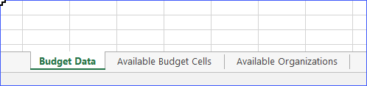

Excel Worksheets

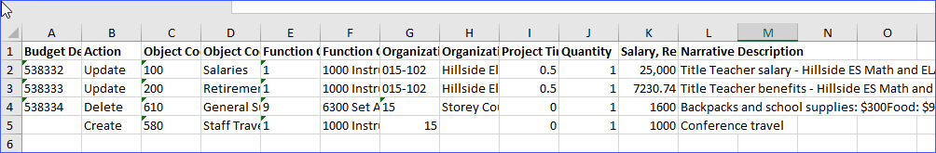

Budget Data Sheet

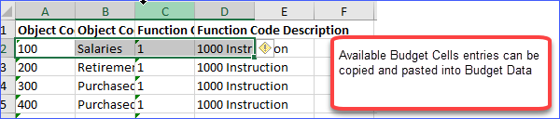

Available Budget Cells

# Tips for Using the Budget Template

* We recommend that a budget template be downloaded whenever a new budget upload is being created so that you are using the most current system information for that budget.
* Columns in the template can be rearranged, but ***it is critical that the text of the column heading remain exactly as downloaded*.**
* Required columns cannot be deleted.
* Additional columns can be added, which will be ignored in the upload process. For example, a column for notes could be added for reference, and it would not create errors nor would the data in these columns affect the budget detail in the upload process.
* Rows for budget details which have no changes can be deleted if desired. However, leaving these rows in the worksheet with the *Update* Action will result in the status quo – no changes will be made if nothing was changed in the Excel file. Note: If you want to remove a budget detail, leave the row with that expense in the worksheet and use *Delete* in the Action column.
* Do not leave blank rows between rows of data in your worksheet, as the system will stop uploading when it comes to a blank row.
* While an entire budget can be uploaded at once, it is also possible to upload only one or a group of budget details.

The Budget Template contains the following columns, some of which are optional.

1. **Item Key (required column, but can be left blank for new budget items)**
   * This column contains the system’s identification for an existing budget detail. **When creating new budget details, this cell will be left blank.**
   * **A value is required for rows that are being updated or deleted.** The value would need to remain the same from the budget download.
2. **Action (required column)**
   * A value is required for this column in every budget detail row.
   * Three possible entries – *Update*, *Delete*, and *Create*.
   * **An existing budget detail can only have *Update* or *Delete.* The default is *Update*.**
   * **New budget details must use the term *Create***.
3. **Object Code (required column)**
   * A value is required for this column in every budget detail row.
   * Can only have a code that is listed on the available Budget Cells tab
4. **Object Code Description (optional column)**
   * This column is included in the budget download template as a reference only. It is not necessary to include this column in the budget upload file.

*Tip: The Object Code, Object Code Description, Function Code and Function Code Description can be copied and pasted from the “Available Budget Cells” worksheet to the appropriate location in the Budget Data sheet. To facilitate copying and pasting, you may find it easier to retain this optional column.*

1. **Function Code (required column)**
   * A value is required for this column in every budget detail row.
   * Can only have a code that is listed on the available Budget Cells sheet
2. **Function Code Description (optional column)**
   * This column is included in the budget download template as a reference only. It is not necessary to include this column in the budget upload file.

*Tip: The Object Code, Object Code Description, Function Code and Function Code Description can be copied and pasted from the “Available Budget Cells” worksheet to the appropriate location in the Budget Data sheet. To facilitate copying and pasting, you may find it easier to retain this optional column.*

1. **Budget Tags (optional column) (see below for how-to)**
   * This column is not required, although depending on the grant, budget tags may be required and validations may be tied to these budget tags.
   * If a budget tag is required or desired but this column is not part of the upload, budget tags can be entered after the budget upload by editing budget details.
   * If this column is included, cells can be left blank.
2. **Organization Number (required column)**
   * A value is required for this column in every budget detail row.
   * Data entered must be on the Available Organization page in the exact format as listed.
3. **Organization (optional column)**
   * This column is included in the budget download template as a reference only. It is not necessary to include this column in the budget upload file.
   * Can be copied and pasted with the code from the Available Organization sheet
4. **Quantity (required column)**
   * A value is required for this column in every budget detail row.
   * Must be greater than 0
   * Data can be entered up to two decimal places.
5. **Cost (required column)**
   * A value is required for this column in every budget detail row.
   * Must be greater than 0
   * Data can be entered up to two decimal places (cents).
6. **Narrative Description (required column)**
   * A value is required. If an upload file is missing one or more required narrative descriptions, an error message will indicate which rows require a value.
   * Limit to 2000 characters
   * Use ALT+Enter to create line breaks in the text.

# Formatting Budget Tags in Your Budget Upload

* **Budget Tag Components.** Every budget tag has two components:
  + The Tag Group Load Name = Prefix for the group of tags (e.g., PF for Primary Function budget tags)
  + Tag Load Name = Code for the individual tag (e.g., AdminEx for Administrative Expenses
* **Creating a Budget Tag String.** For each budget tag group you want to add, you will need a string starting with the Prefix, then add “=”, then add the tag load name (e.g., PF=EVAL for Primary Function Evaluation of programs/curricula). This string appears for each tag in the “Upload Text” (Column E) column of the Available Budget Tags worksheet.
* **Multiple Tags, Same Group:** If you want to add more than one budget tag from a tag group (when it is permissible to choose multiple tags), you will use the Prefix and “=” only once, and then add subsequent tag load names separated by a comma and a space. For example, where the Tag Group is Required Uses of Funds (Prefix UseOfFunds), adding tags for Uses 1, 3, 4, 5 and 6 looks like this:

**UseOfFunds=UseOfFunds1, UseOfFunds3, UseOfFunds4, UseOfFunds5, UseOfFunds6**

* **Multiple Tag Groups**: Finally, if you want to include tags from multiple tag groups, you will separate the groups with a colon (no spaces or a space after the colon). For example, if you want to add a tag from the Primary Function Group for Skillbuilding for Quality Careers (PF=SKILL), and a tag from the Required Uses of Funds group for Providing instructors professional development (UseOfFunds=UseOfFunds2), you would connect them as follows:

**PF=SKILL: UseOfFunds=UseOfFunds2** *or* **PF=SKILL:UseOfFunds=UseOfFunds2**

**An example:**

Steps for Creating or Modifying a Budget

1. 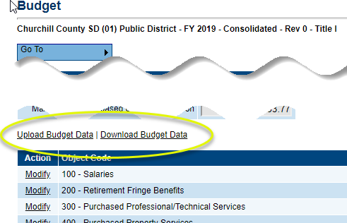From the Budget page click on *Download Budget Data*. This will download an Excel file containing the budget data and other information specific to the grant.
2. Open the downloaded Excel file. The column headings in the file must not be renamed nor required columns deleted. However, the columns can be reordered if desired. Make any desired changes to any existing budget details. The default Action value is *Update* (if the budget was downloaded with existing budget items) which indicates a change to data within the budget detail. To delete a budget detail, use *Delete* in the Actioncolumn. Create new budget details as needed, putting *Create* in the Action column.  
     
   If creating a budget “from scratch,” or to provide a user with a blank upload file, use *Download Budget Data* before any budget details are created or download the budget and delete all the **rows** except the one with the column headings. This process could be used to provide an empty spreadsheet to individual schools for creating their own budgets. The completed sheets would be copied into the district budget.
3. Save the file to your computer with an appropriate file name.
4. From the Budget page, click on *Upload Budget Data*.
5. Graphical user interface, application

   Description automatically generatedLocate the file by clicking on *Choose File* and navigating to the place on your computer where you have saved the file, click Open. To upload, click on *Create* after choosing your file.

* If the file is missing any required data, an error message will appear and the file will not be uploaded. Open the file in Excel, enter the missing data, save the file and upload again.

1. If the file uploads, the system will display the Grant Budget Upload Screen.

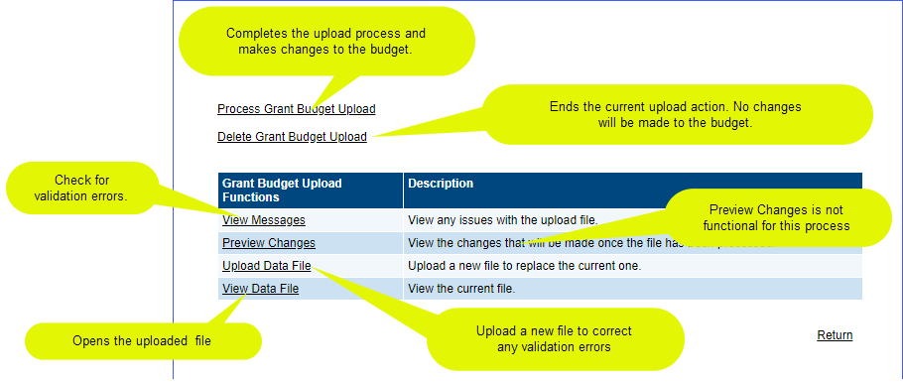

Budget Upload Screen

1. 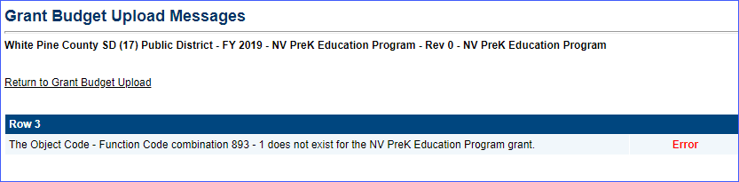Click on *View Messages* to see if there are any validation errors. An error will prevent the file from being processed. If errors exist, correct them in the Excel file and click on *Upload Data* from this screen to load the corrected file.
2. If there are no error messages, click *Process Grant Budget Upload* to complete the budget upload.
3. 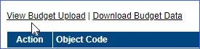A budget upload must be processed before another one can be started. If a budget upload has been started but not completed, the Budget page will display a *View Budget Upload* link. If you do not want to complete the current budget upload process for any reason, click on *Delete Grant Budget Upload.* No changes will be made to the budget.

Tip: Your budget upload worksheet can have as many worksheets as you want as long as the current upload appears as the first sheet. The system “reads” from the first worksheet only.

# What is filtering?

Filtering provides a way to view and download a subset of budget details. The filtering criteria include object codes, function codes, LEA/School organizations, and tags. A filter must include criteria for Object Codes, Function Codes and LEA/ School. Filtering by Tags is optional.

Filtering of budget data takes place on the Budget Detail page. Filtering of data can take place regardless of the application status.

To filter, select Modify or View (depending on the application status) for any of the object or function groups on the Budget page.

1. On the Budget Detail page, the filter options are at the top right and will be filtered by default for the code selected and “all” for the other filters. The budget details that are listed will only include those that match the filter criteria. Select the *Show All* link to the far right to see all created budget details.

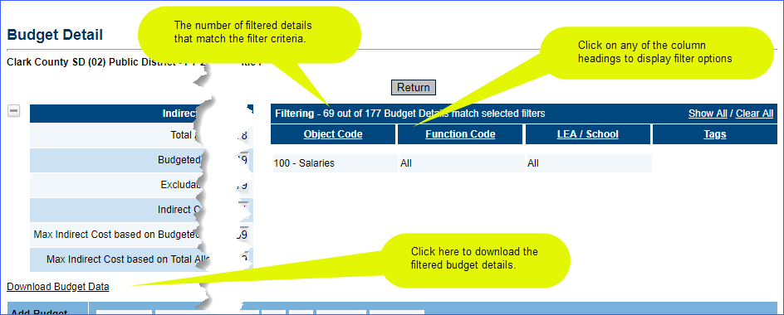

1. 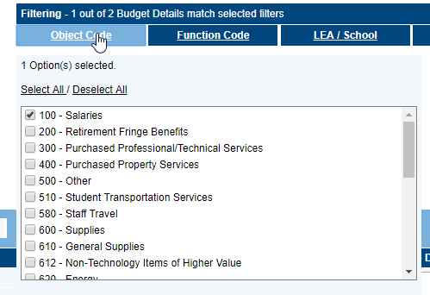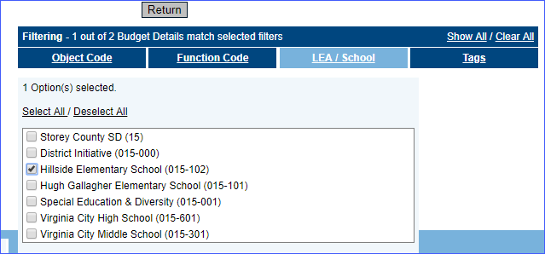To apply other filter criteria, click on the underlined criteria to display a list of options. Criteria options can include one or more individual selections or all of the options.
2. Once the filter criteria are applied,
   1. the number of budget details resulting from the filter will appear in the filter header,

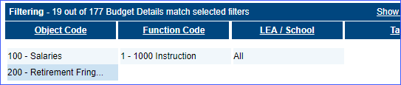

* 1. 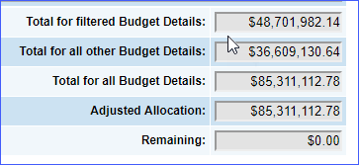the budget summary will include a total for the filtered details, and
  2. 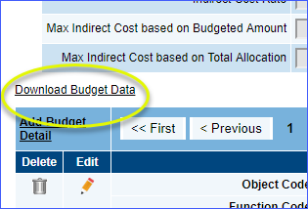selecting the *Download Budget Data* link will download the filtered budget details to an Excel template file for printing or other use.

# FAQ

**Can an budget details still be edited directly in GEM$?**

Yes. For this reason it is important to download a budget before making any new uploads.

**Can I download data from previous FY budgets?**

Yes. The download link will appear on all previous year budget pages.

**Can I download a budget without doing a budget upload?**

Yes. The download feature can be used to create a file for printing, distribution, ad hoc reports, or for viewing large numbers of budget details at once.