Instructions for Completing the FY25 ESSA Program Monitoring by Role
Click for instructions for your role:
LEA ESSA Consolidated Grantwriter
LEA Superintendent/Chief Executive

Role: LEA ESSA Consolidated Grantwriter
- Sign into GEM$ using your email address and password: https://mass.egrantsmanagement.com/

- Navigate to the grey menu on the left of the screen, choose “Application Supplement” then “Application Supplements” (do not click on your organization link – that is for funding applications/grants only):
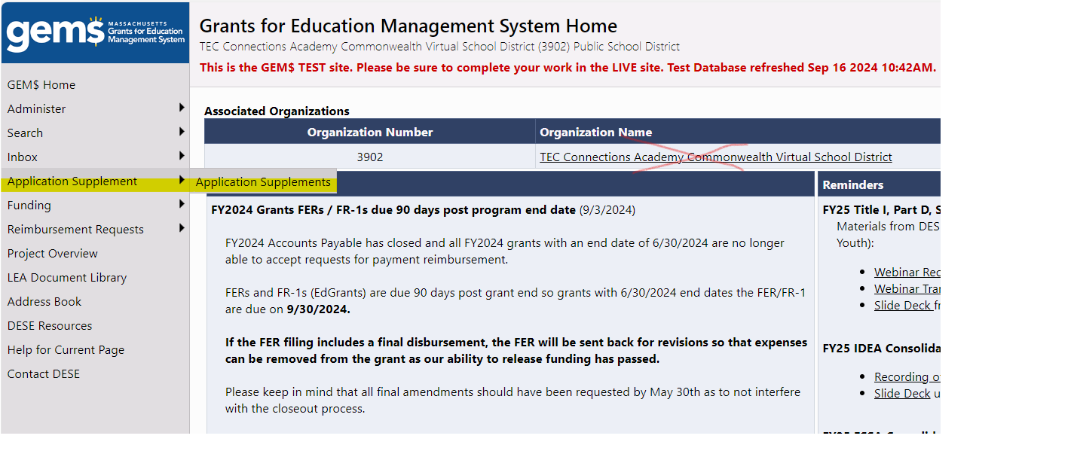

- Be sure to select 2025 from the dropdown menu and then click on the FY24 ESSA Program Monitoring Contacts .
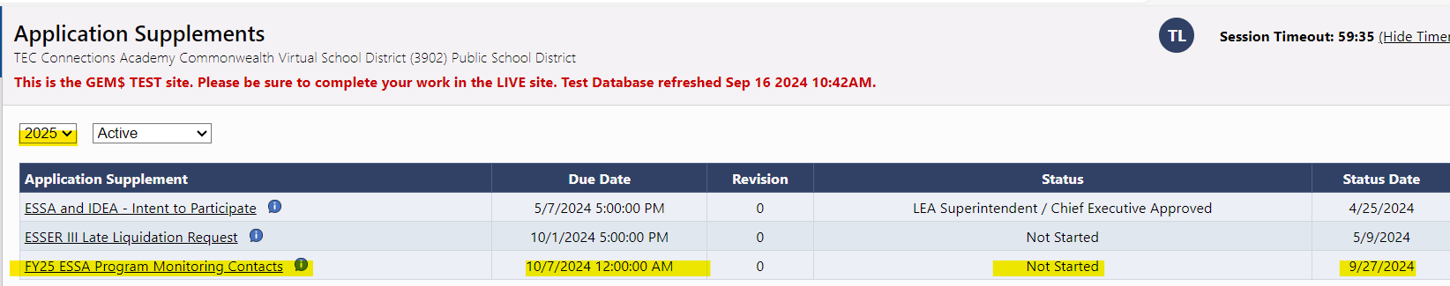

- From the sections page, BE SURE TO SELECT “APPLICATION SUPPLEMENT STARTED” AT THE TOP LEFT, and confirm, or you will not be able to enter data in the Monitoring Contact Supplement.
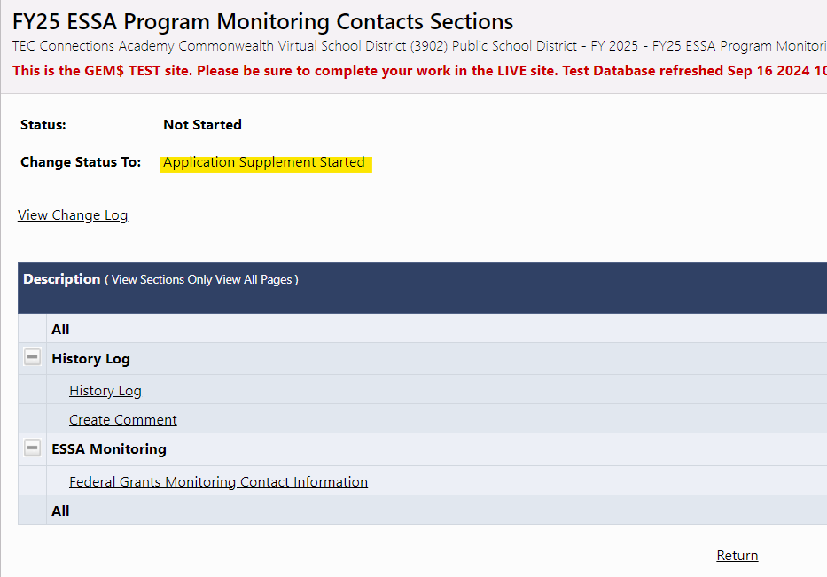

- Then choose Federal Grants Monitoring Contact Information from the Sections page and complete all information for your district. Note that starred (*) items are required to be completed or you will receive a validation error message and will not be able to submit your Monitoring Contact supplement (circled in red).
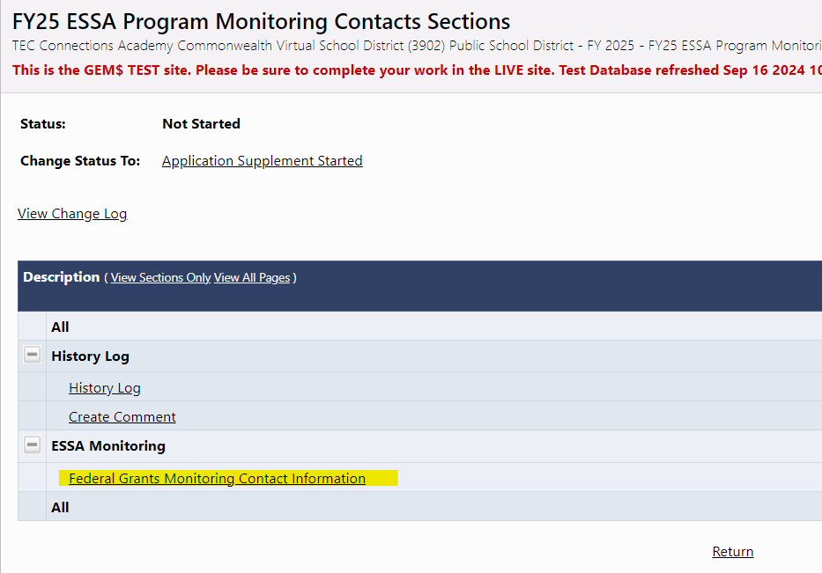

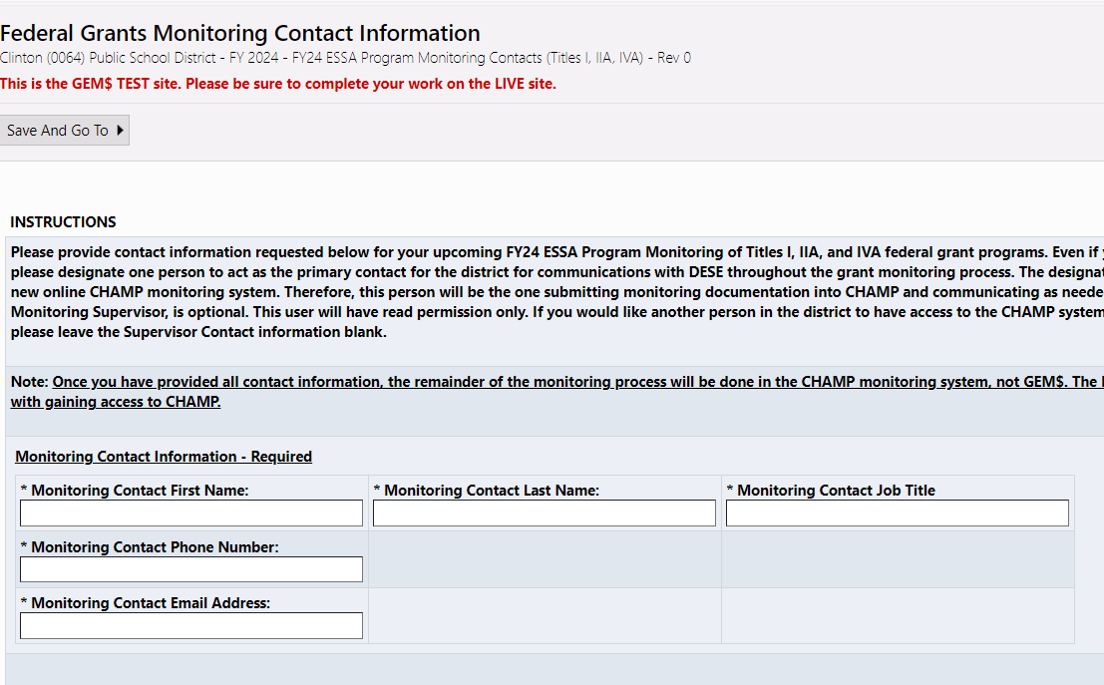
- When you have completed this page, return to the Sections page and move the Monitoring Contacts Supplement to your LEA Superintendent/Chief Executive for approval by choosing “LEA Grantwriter Submitted” link at the top left of the page and confirm.

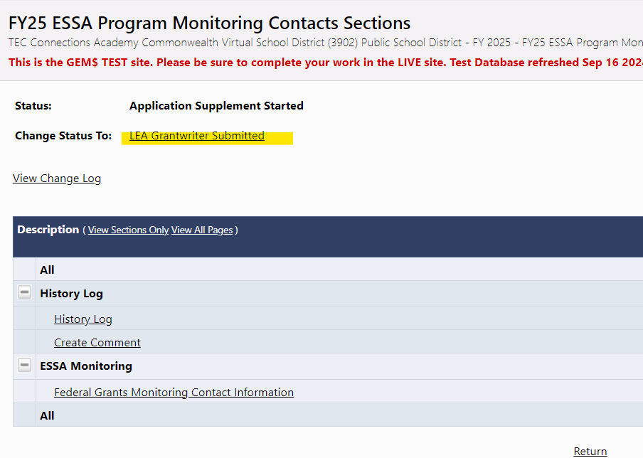

- If you believe you have completed the Monitoring Contacts Supplement, but get messages on the Sections page, click on the Messages link and correct any errors.
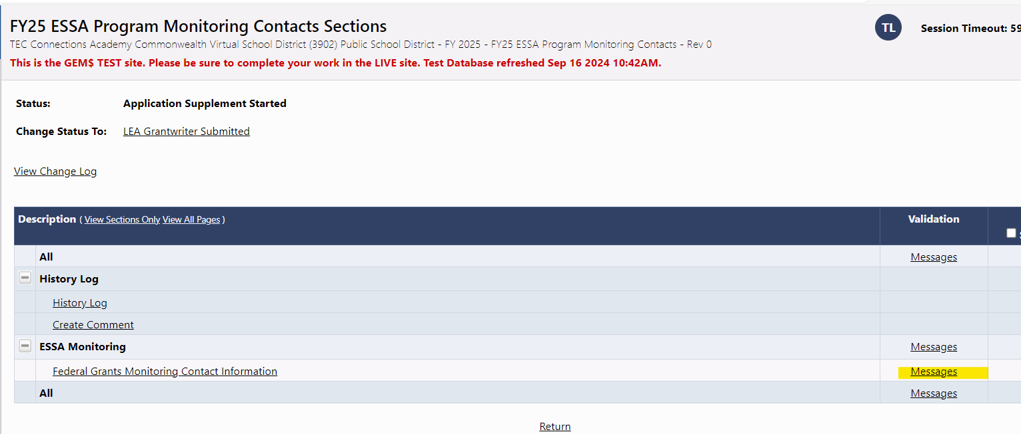

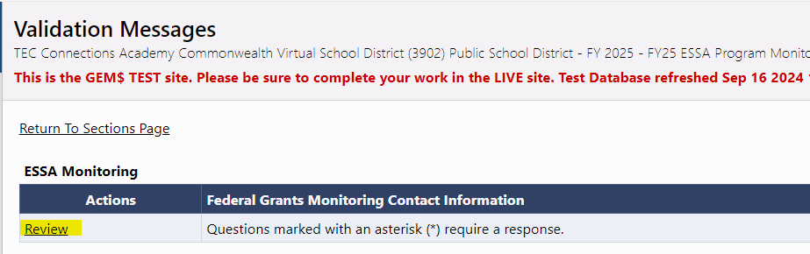
- Clicking on the “Review” button for any validation message will bring you to the page with the error.

- Once errors have been resolved, click “LEA Grantwriter Submitted” to move to your Superintendent/Chief Executive.
Role: LEA Superintendent/Chief Executive
- You will receive a “No Reply” email from GEM$ indicating that your LEA Grantwriter has approved the Monitoring Contacts Supplement. This is your cue to approve.

- Sign into GEM$ using your email address and password: https://mass.egrantsmanagement.com/

- Navigate to the grey menu on the left of the screen, choose “Application Supplement” and then “Application Supplements”

- Be sure to select 2025 from the dropdown menu and then click on FY24 ESSA Program Monitoring Contacts.

- On the Sections page (opening page when you click on the FY25 ESSA Program Monitoring Contacts), you can click on the link “Federal Grants Monitoring Contact Information” and review the answers for your district.

- When satisfied, go back to the Sections page and select, “LEA Superintendent/Chief Executive Approved” and confirm by checking the attestation, this will submit the Monitoring Contact to DESE and you are finished. DESE will contact your grantwriter with any questions.

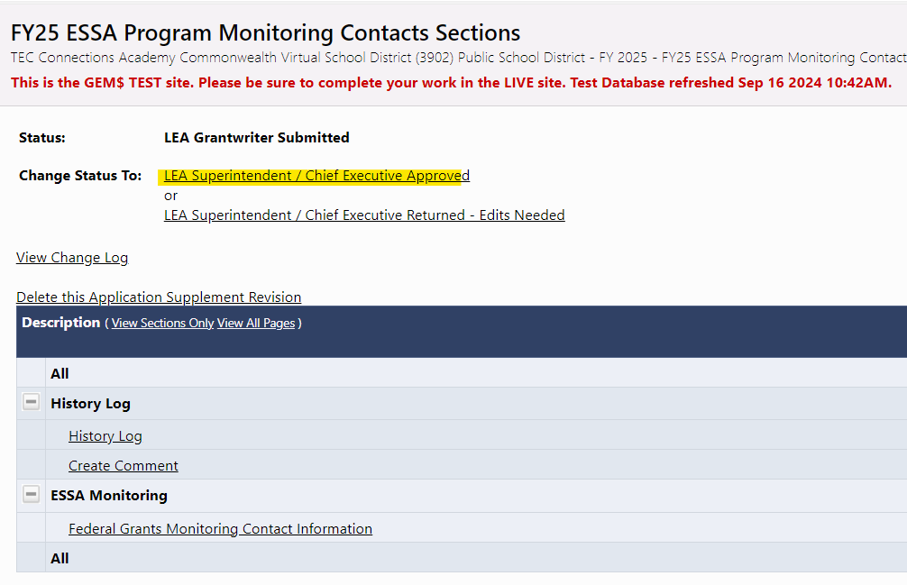

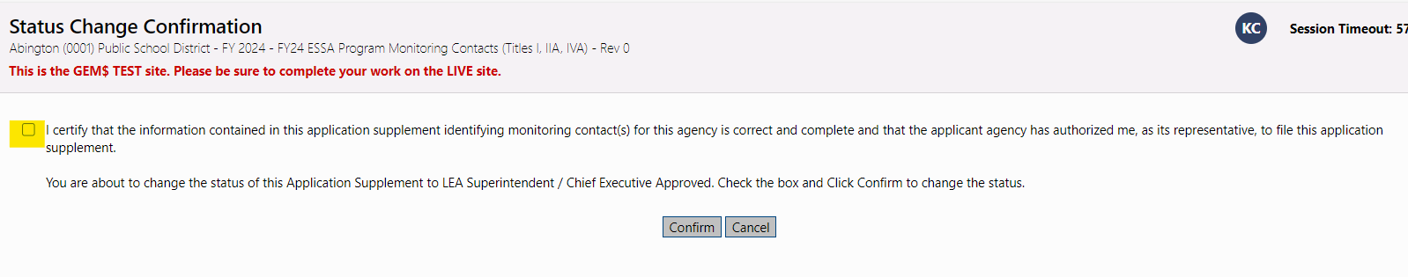

- If you want your grantwriter to fix any answer, you can choose “LEA Superintendent/Chief Executive Returned – Edits Needed” and your grantwriter will fix and send it back to you for approval.
