**GEM$ User Guide for LEAs**

***Requirements and Best Practices for Assigning and Using Roles in GEM$***

*DESE’s Grants for Education Management System (GEM$) provides substantial new flexibilities and autonomies to grant applicants (referred to as local education agencies, or LEAs). One of those flexibilities is that DESE (in the first instance) can enable an LEA User Access Administrator (UAA) to create roles for all subsequent LEA GEM$ users. This guidance is designed to describe the capabilities and responsibilities that each role has in GEM$ and DESE’s expectations for how these roles will be used and managed*.

**User Roles**

*Once a role is assigned in GEM$, it remains with the person assigned until removed by the UAA. Grant-specific roles, like LEA Grantwriter, do not need to be re-assigned every year. Note: Once a district creates a User in GEM$, they cannot be deleted, but all of their roles can be removed so that they no longer have access.*

| Role | | Capabilities and Responsibilities | DESE Requirements and Expectations |
| --- | --- | --- | --- |
| 1. User Access Administrator (UAA) | **This role:**   * **Sets all roles for the LEA.** * **Can view all funding applications, application supplements, and reimbursement activity for their LEA.** * **Manages all roles for the LEA, keeping a centralized list of each GEM$ user and which roles each holds.** * **Promptly removes any user role that is no longer necessary due to staff turnover or change of job responsibilities.** * **Can be held by more than one person.** | | * **This role allows assigning any LEA role in GEM$. As a result, the UAAs should be authorized by the organizational leadership and should be limited in number.** * **The original UAA is appointed by DESE and must come through the superintendent using this** [**form**](https://mass.egrantsmanagement.com/DocumentLibrary/ViewDocument.aspx?DocumentGuid=13575ea8-4ffd-463e-9d16-758897d5f9f4&inline=true)**.** * **Subsequent staff who are given the UAA role must file a** [**form**](https://mass.egrantsmanagement.com/DocumentLibrary/ViewDocument.aspx?DocumentGuid=4f01d9fb-b7a3-4cdc-af93-08dd09f69054&inline=true)**, signed by the superintendent, in GEM$ using their LEA Document Library.** * **A copy of the User Role form for this role should also be kept on file with the LEA.** * **Users and their roles should be reviewed at least annually to ensure all assigned roles are still necessary.** * **User roles that have become obsolete because of staff turnover, job changes, or grants that are no longer available to the LEA should be removed within 3 business days.** * **Annually, districts will be required to certify that the LEA roles have been reviewed and comply with this guidance.** * **Vendors/contractors should not be assigned this role. In the rare case that a vendor/contractor is the only option to fill this role, the LEA must first seek written authorization from DESE.** |

|  |  |  |  |
| --- | --- | --- | --- |
| 1. LEA Grantwriter | This role:   * Is created by the UAA separately for each funding application and can be held by more than one person. * Can start and complete the designated funding application and move it to the next step of the workflow for approval­­­­­­­­. * Can view all funding applications, application supplements, and reimbursement activity for their LEA. | | * Staff needing this role should contact their LEA’s UAA and complete the proper [forms](https://mass.egrantsmanagement.com/DocumentLibrary/ViewDocument.aspx?DocumentGuid=26588f12-60fc-47e4-864a-a266cd7195e4&inline=true). * This role will need to be in place for each funding application for which the LEA is eligible before the application can be started. * This role starts all funding applications. |
| 1. LEA Fiscal Representative | **This role:**   * **Is created by the UAA once for all funding applications and can be held by more than one person.** * **Must review and approve any funding application completed by the LEA Grantwriter.** * **Reviews the Chart of Accounts designations for each budgeted expense of a funding application to assure alignment with end-of-year spending categories.** * **Has the ability to edit any funding application while it is with the LEA Grantwriter.** * **Provides an assurance on behalf of the district when approving the funding application.** * **Is the only role that can submit reimbursement requests and final expenditure reports (formerly FR-1s) for any grant.** * **Can view all funding applications, application supplements, and reimbursement activity for their LEA.** | | * **This role should be assigned to the highest-level business officer at your organization.** * **If additional staff are assigned this role, they should be associated with the business office/fiscal side of the LEA’s grant operations.** * **For entitlement grants, the approval of the LEA Fiscal Representative establishes the start date for this grant. Therefore, the funding application should be substantially approvable before the Fiscal Representative approves, including having all budgeted expenses with appropriate function and object codes.** * **Staff needing this role should contact their LEA’s UAA and complete the proper** [**forms**](https://mass.egrantsmanagement.com/DocumentLibrary/ViewDocument.aspx?DocumentGuid=26588f12-60fc-47e4-864a-a266cd7195e4&inline=true)**.** |
| 1. LEA Superintendent/   Chief Executive  LEA Superintendent/  Chief Executive (cont.) | | **This role:**   * **Is created by the UAA once for all funding applications and can be held by more than one person.** * **Must review and approve any funding application as the final step in the LEA workflow.** * **Has the ability to edit any funding application while it is with the LEA Grantwriter.** * **Provides an assurance on behalf of the district when approving the funding application.** * **Can view all funding applications, application supplements, and reimbursement activity for their LEA.** | * **This role should be assigned to the superintendent/chief executive/leader of your organization using the proper** [**form**](https://mass.egrantsmanagement.com/DocumentLibrary/ViewDocument.aspx?DocumentGuid=c6751514-6e14-4421-b5da-2e6b59f4e839&inline=true)**.** * **Any person assigned the superintendent/chief executive role must file a** [**form**](https://mass.egrantsmanagement.com/DocumentLibrary/ViewDocument.aspx?DocumentGuid=c6751514-6e14-4421-b5da-2e6b59f4e839&inline=true)**, signed by the superintendent, in GEM$ using their LEA Document Library.** * **All staff, including any surrogate for the actual superintendent/chief executive, holding this role must be authorized to sign contracts and therefore must be designated on the LEA’s CASL form (Contractor Authorized Signatory Listing) on file with DESE’s Grants Management office.* The CASL form is used to validate authorized signatories to protect vendors and the Commonwealth from fraud. All Contractors (LEAs/grantees) must provide a listing of individuals who are authorized as legal representatives of the Contractor (LEAs/grantees) who can sign contracts and other legally binding documents related to the contract on the Contractor’s (LEA’s/grantee’s) behalf.** * **The actual superintendent/chief executive/leader of your organization should approve all funding applications except in rare instances of prolonged unavailability. Failure to follow this requirement may result in returning the funding application for re-approval or delaying availability of funding.** * **Vendors/contractors should not be assigned this role. In the rare case that a vendor/contractor is the only option to fill this role, the LEA must first seek written authorization from DESE.** |
| 1. LEA Update | **This role:**   * **Is created by the UAA separately for each funding application and can be held by more than one person.** * **Can edit a funding application, but cannot start or move a funding application ahead for approval.** * **Can view all funding applications, application supplements, and reimbursement activity for their LEA.** | | * **This role is limited and should be given to those who assist in the preparation of funding applications, but do not have primary responsibility.** * **Staff needing this role should contact their LEA’s UAA and complete the proper** [**forms**](https://mass.egrantsmanagement.com/DocumentLibrary/ViewDocument.aspx?DocumentGuid=26588f12-60fc-47e4-864a-a266cd7195e4&inline=true)**.** |
| 1. LEA Data View | **This role:**   * **Is created by the UAA once for all funding applications and can be held by more than one person.** * **Can view all funding applications, application supplements, and reimbursement activity for their LEA.** * **Cannot change anything in GEM$.** | | * **This role is limited and can be given to allow staff to review and/or monitor grant-related activity.** * **Staff needing this role should contact their LEA’s UAA and complete the proper** [**forms**](https://mass.egrantsmanagement.com/DocumentLibrary/ViewDocument.aspx?DocumentGuid=26588f12-60fc-47e4-864a-a266cd7195e4&inline=true)**.** |

**\* Exception: For Community Colleges and state agencies/entities that have an ISA (intrastate agreement) with DESE, the person signing off as the Superintendent/Chief Executive should be the head of the organization or other senior administrator, preferably the senior administrator who is the signatory appearing on the ISA. These entities are not required to file a CASL with DESE.**

**Workflows**

The GEM$ funding applications will have one of **two types workflows**\*:

1. Entitlement/targeted/continuation grants/funding applications (Entitlement Workflow) for grants where funding has been allocated to an LEA pending and approved application
2. Competitive grants/funding applications (Competitive Workflow). Diagrams for both workflows are found at the end of this document.

Both workflows contain **three LEA steps** for any status (original, corrections, revision (fka amendment)) of a funding application in GEM$:

1. LEA Grantwriter submission
2. LEA Fiscal Representative approval
3. LEA Superintendent/Chief Executive approval

These steps are required in a different order, because of DESE program/fiscal reviews and approvals, in the Entitlement versus the Competitive Workflow. Note that any correction or revision to an existing funding application restarts the respective workflow.

\**Application Supplements in GEM$, which are data collection tools, have a variety of workflows that may include the Grantwriter alone or in combination with the Fiscal Representative and/or the Superintendent/Chief Executive. Consult the Application Supplement to determine the workflow.*

**Workflow and Approval - Requirements**

**Regardless of the type of workflow, the following requirements must be observed:**

*Failure to follow these requirements will result in return of your funding application and possibly delay availability of funding.*

1. **The actual Superintendent/Chief Executive should be approving each funding application as the last LEA step in the workflow.**
2. **In no case should the same person be submitting/approving a funding application in all LEA roles.**
3. **Every instance of a funding application going through a workflow in GEM$ (whether it be a correction or revision/amendment), must have at least two different people submitting/approving for the LEA.**
4. **If a surrogate is needed because the actual Superintendent/Chief Executive is not available such that a grant will be unreasonably delayed, that surrogate must be listed as an authorized signatory on the LEA’s current CASL form that has been submitted to DESE (see exception, noted above (*) for Community Colleges and other state entities with an ISA with DESE).**

**Role Assignment and Management – Forms**

DESE has created the following forms for various roles that should be downloaded and used by every LEA, as necessary. Note that forms should be completed, signed, and, if necessary, uploaded to GEM$ prior to role assignment:

NBC

|  |  |  |
| --- | --- | --- |
| Name of Form | Brief Description | Who gets it |
| [Original UAA Role Request form](https://mass.egrantsmanagement.com/DocumentLibrary/ViewDocument.aspx?DocumentGuid=13575ea8-4ffd-463e-9d16-758897d5f9f4&inline=true) | This form is used for LEAs that are applying in GEM$ for the *first* time and *do not have any existing role holders in GEM$.* Subsequent UAAs may be created by the LEA’s UAA upon completion of the appropriate form. | Email to DESE grant/funding application contact listed on RFP. Once received, DESE will create this UAA role for your LEA in GEM$. |
| [LEA Alternate User Access Administrator](https://mass.egrantsmanagement.com/DocumentLibrary/ViewDocument.aspx?DocumentGuid=4f01d9fb-b7a3-4cdc-af93-08dd09f69054&inline=true) or [Superintendent/Chief Executive Role form](https://mass.egrantsmanagement.com/DocumentLibrary/ViewDocument.aspx?DocumentGuid=c6751514-6e14-4421-b5da-2e6b59f4e839&inline=true) | These forms are for any person who will be approved to act as the LEA User Access Administrator or LEA Superintendent/Chief Executive in GEM$. For the latter, a form should be used for the actual Superintendent/Chief Executive. The actual Superintendent, as well as any additional staff holding this role must appear on the LEA’s CASL form on file with DESE (see above exception (*) for Community Colleges and those with ISA with DESE). | Upload completed forms to your LEA Document Library – once uploaded, the LEA’s UAA may create this role in GEM$. |
| [LEA General User Role form](https://mass.egrantsmanagement.com/DocumentLibrary/ViewDocument.aspx?DocumentGuid=26588f12-60fc-47e4-864a-a266cd7195e4&inline=true) | This form will be used for any LEA role in GEM$ other than the Superintendent/Chief Executive or User Access Administrator. | UAA will retain fully executed forms, which may be requested by DESE at any time for monitoring. Once form is complete and signed, LEA’s UAA may create roles. |
| [LEA Request to Include Contractor/Vendor in Key Role form](https://mass.egrantsmanagement.com/DocumentLibrary/ViewDocument.aspx?DocumentGuid=e092dd3f-7b89-49b6-b00b-a95b397d3fde&inline=true) | In almost all cases, vendors/contractors should not be assigned the role of LEA User Access Administrator and/or Superintendent/Chief Executive. In the rare case that a vendor/contractor is the only option to fill this role, the LEA must use this form to first seek written authorization from DESE. | Email to DESE’s Grants Management Office. DESE must approve this form prior to the LEA’s UAA assigning either of these roles to a vendor/contractor. |

**LEA User Role Forms**

*Below is brief explanation of the forms applicable to user roles in GEM$. The name of the form is linked to a template of that form for your convenience.*

**User Role Forms – Pathways for Forms by Type**

*These pathways show the required steps for forms for each user role in GEM$. For a standalone version of this diagram, click* [*here*](https://mass.egrantsmanagement.com/DocumentLibrary/ViewDocument.aspx?DocumentGuid=09714a36-86f8-4d05-91de-73992e8ba70e&inline=true)*.*

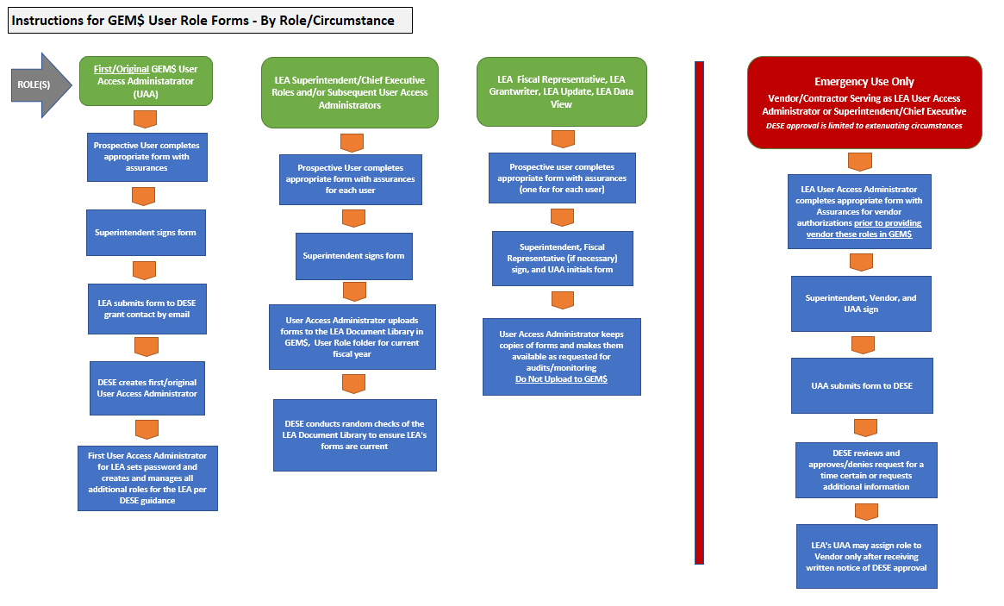

**GEM$ FUNDING APPLICATION WORKFLOWS**

*These diagrams show the funding application (grant) workflow for the two major types of grants (entitlement (also continuation and targeted) and competitive).*

