FY2026
FC 0310 – McKinney-Vento Homeless Education Grant (competitive)

Questions and Answers

Please email questions to achievement@mass.gov with the
Subject Line: FY2026 FC 0310 Question

Questions and responses will be posted here and updated periodically until the grant due date.

Table of Contents
Important information 1
Questions through May 16 2025 1

Important information
Accessing the application in GEM$: All eligible entities have access to the application in GEM$. In order to begin an application, the entity’s User Access Administrator must assign the role of LEA FC 0310 McKinney Vento Homeless Education Grant (Federal/COMP) Grantwriter.
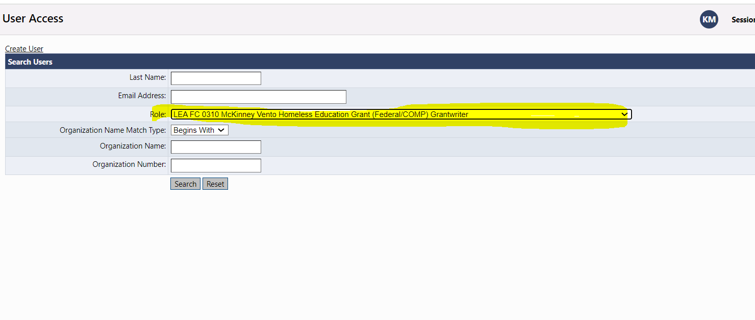
For first-time GEM$ users, see the GEM$ Submission Instructions section in the RFP (https://www.doe.mass.edu/grants/2026/0310/) for additional information about how to access GEM$ and submit an application.

Questions through May 16 2025
- Does the total # of enrolled students include both homeless and foster care or just homeless?
The total number of enrolled students in the FC310 McKinney Vento Homeless Education competitive grant application is for homeless students.

- When do you think this grant will be posted in GEMS?
The grant application for FC310 is available in GEM$. For details on how to access GEM$, please refer to the important information section above.

- I noticed that the McKinney Vento grant posted yesterday, however it is not available in GEM$ for FY26. Will it take a few days for it be able to view in GEM$?

The grant application for FC310 is available in GEM$. For details on how to access GEM$, please refer to the important information section above.

- Where can I find the applicant criteria and job description for the regional Liaison TA Specialist?
The applicant criteria and the job description of the Regional Technical Assistance Specialist can be found in the GEM$ FC310 grant application related document section.

