**FY26 Instructions for Completing Intent to Participate by Role**

**Click for instructions for your role:**

**User Access Administrator**

**LEA IDEA or ESSA Consolidated Grantwriter**

**LEA Fiscal Representative**

**LEA Superintendent/Chief Executive**

**Role: User Access Administrator (UAA)**

* To complete the Intent to participate, be sure that you have assigned the following roles for your district/organization.
  + LEA IDEA Consolidated Grantwriter or LEA ESSA Consolidated Grantwriter
  + LEA Fiscal Representative
  + LEA Superintendent/Chief Executive

**Role: LEA IDEA Consolidated Grantwriter or LEA ESSA Consolidated Grantwriter**

* Sign into GEM$ using your email address and password: <https://mass.egrantsmanagement.com/>
* Navigate to the grey menu on the left of the screen, choose “Application Supplement” “Application Supplements”:

* Be sure to select 2026 from the dropdown menu and then click on the Intent to Participate

* From the sections page, **BE SURE TO SELECT “APPLICATION SUPPLEMENT STARTED” AT THE TOP LEFT, and confirm, or you will not be able to enter data in the Intent to Participate.**

* Then choose each of the links under the “ESSA and IDEA – Intent to Participate” and answer for your district – all grants must be completed even if you are not eligible for a fund code (the Title I School Changes page does not need to be completed if not applicable).
* **For Title I only: There is no option for a Title I Consortium this year – all districts with a Title I allocation must complete their own Title I application to apply for their Title I funds. Contact your federal grants liaison with any questions.**

* **Title I School Changes: Districts with changes to school configurations for the school year 2025-2026 (SY26) that were not reported in March 2025 SIMS data should use the Title I School Changes page to report anticipated changes.**
  + Include any school that will be closed, opened (new school), or change grade configurations/merge in the fall that was not reflected in your March SIMS data.
  + Complete for all school changes, not just those that were designated as Title I schools in the past.
  + Fill out all columns of the table, including total enrollment and total low-income students.
  + **Do not include pre-kindergarten students in enrollment totals.**
  + If you need to estimate enrollments, do so based on the current school year’s data and how students will be reassigned from existing schools to the newly configured school for SY26.
  + Do not include schools with small changes in enrollment without an accompanying change in grade configurations or official merger.
* When you have filled in a choice for each Fund Code and, if applicable the Title I School Changes page, return to the Sections page and move the Intent to Participate to your Fiscal Representative by choosing “Application Supplement Completed” link at the top left of the page and confirm.

* If you believe you have completed all Fund Codes, but get messages on the Sections page, click on the Messages link and correct any errors.

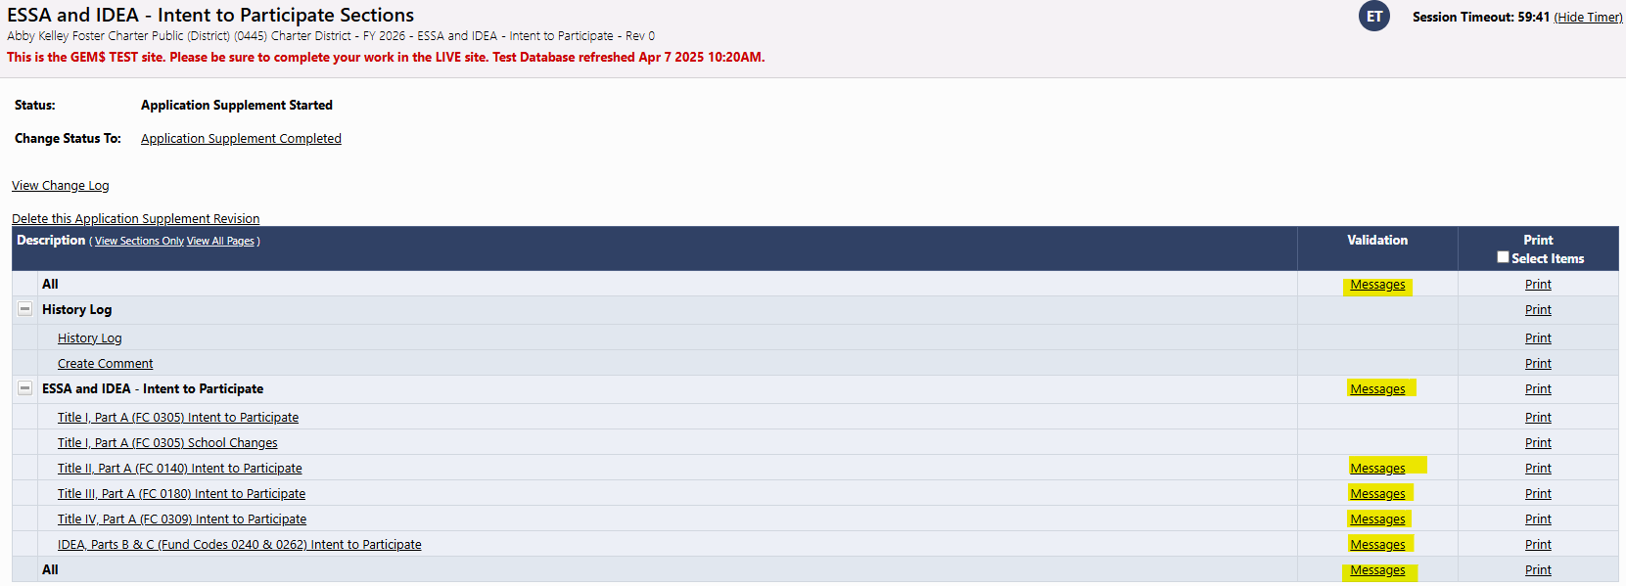

* Background pattern

  AI-generated content may be incorrect.Clicking on the “Review” button for any validation message will bring you to the page with the error.
* Once errors have been resolved, click “Application Supplement Completed” to move the Intent to Participate to your Fiscal Representative for review and approval.

**Role: Fiscal Representatives**

* You will receive a “No Reply” email from GEM$ indicating that your LEA Consolidated Grantwriter (ESSA or IDEA) has completed the Application Supplement/Intent to Participate. **This is your cue to approve.**
* Sign into GEM$ using your email address and password: <https://mass.egrantsmanagement.com/>
* Navigate to the grey menu on the left of the screen, choose “Application Supplement” “Application Supplements”:

* Be sure to select 2026 from the dropdown menu and then click on the Intent to Participate

* On the Sections page (opening page when you click on the ESSA and IDEA – Intent to Participate), you can click through the links under “ESSA and IDEA - Intent to Participate” and review the answers for your district.
* 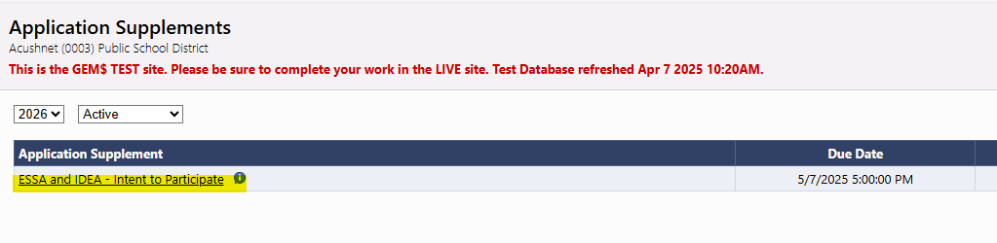
* If satisfied, go back to the Sections page and select, “LEA Fiscal Representative Approved” and confirm, this will pass the Intent to Participate ahead to your Superintendent/Chief Executive for final approval.

* If you want your grantwriter to amend any answer, you can choose “LEA Fiscal Representative Returned – Edits Needed” and your grantwriter will fix and send it back to you for approval.

**Role: Superintendent/Chief Executive**

* You will receive a “No Reply” email from GEM$ indicating that your LEA Fiscal Representative has approved the Application Supplement/Intent to Participate. **This is your cue to approve.**
* Sign into GEM$ using your email address and password: <https://mass.egrantsmanagement.com/>
* 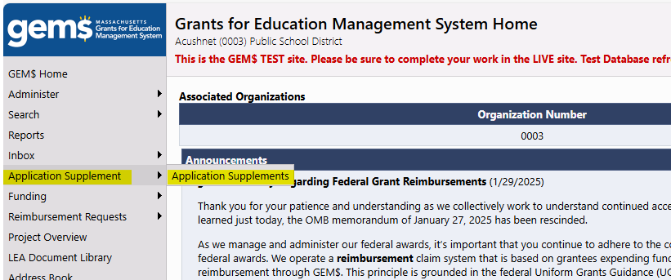Navigate to the grey menu on the left of the screen, choose “Application Supplement” “Application Supplements”:
* Be sure to select 2026 from the dropdown menu and then click on the Intent to Participate

* On the Sections page (opening page when you click on the ESSA and IDEA – Intent to Participate), you can click through the links under “ESSA and IDEA - Intent to Participate” and review the answers for your district.

* Graphical user interface, text, application

  AI-generated content may be incorrect.If satisfied, go back to the Sections page and select, “LEA Superintendent/Chief Executive Approved” and confirm by checking the attestation, this will submit the Intent to Participate to DESE and you are finished. DESE will contact your grantwriter with any questions.

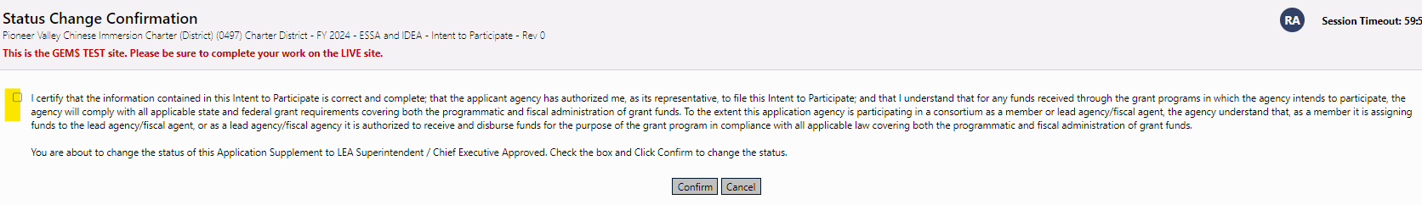

* If you want your grantwriter to amend any answer, you can choose “LEA Superintendent/Chief Executive Returned – Edits Needed” and your grantwriter will fix and send it back to your fiscal representative and then you for approval.

