GEM$ Final Expenditure Report (FER) Submission Process for LEA Fiscal Representatives
The Final Expenditure Report (FER) is a required process to complete the grant cycle and close the grant. FERs must be filed 90 days after the grant end date.
- Prerequisites to filing the FER
The following criteria must be met before the GEM$ system will allow you to start the FER:
- The Grant Project Duration (Period of Performance) end date has passed OR all grant funds have been requested, received, and marked as paid
- All application revisions have been completed, and the grant status is DESE Fiscal Budget Approved.
- Any Reimbursement Requests associated with the grant are at State Accounting System Paid status. Reimbursement Requests statuses can be viewed on the Project Summary screen:

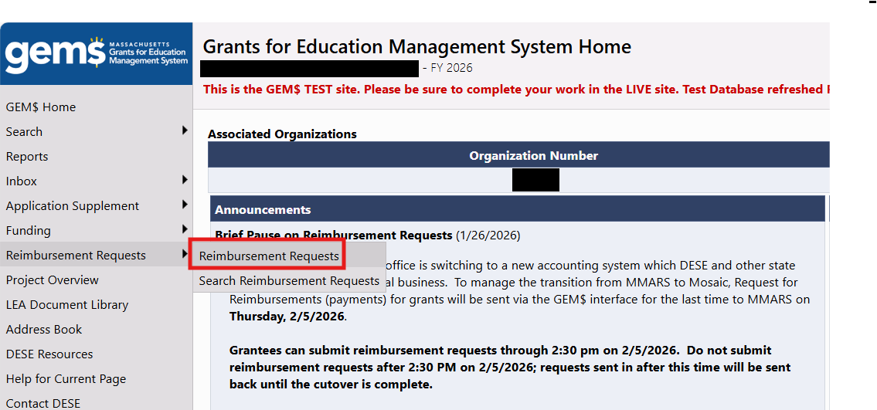

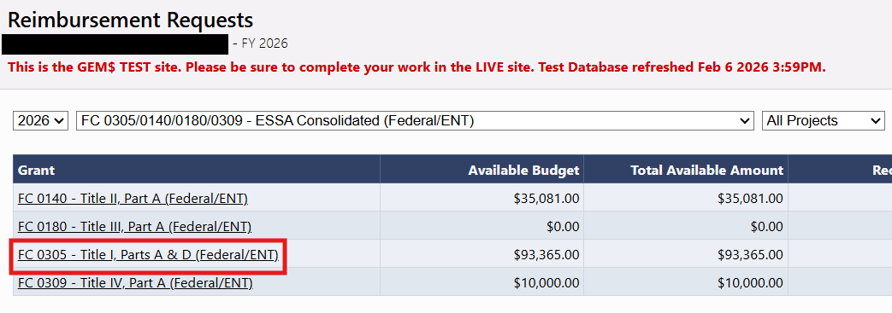

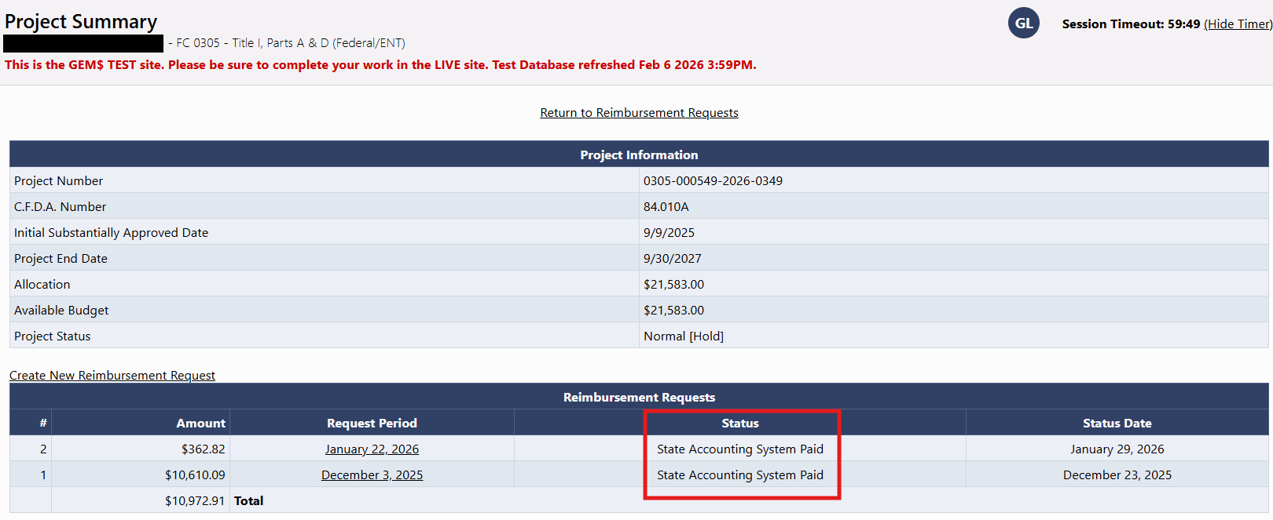

If you have recently submitted a Reimbursement Request, you must wait until it has been marked paid in GEM$ before you can submit the FER. If you started a Reimbursement Request in error, you can cancel the request by opening it from the Project Summary page and changing the status to Delete Reimbursement Request:

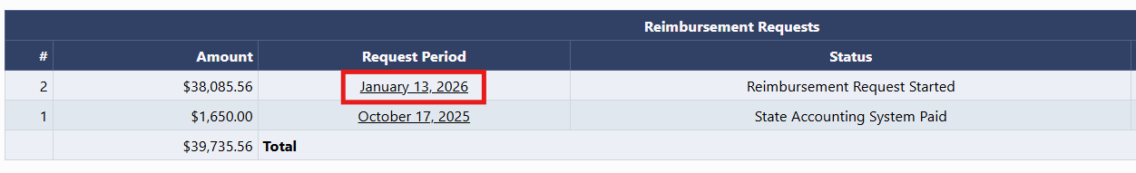

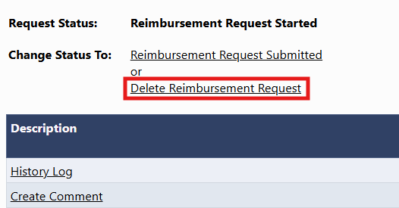

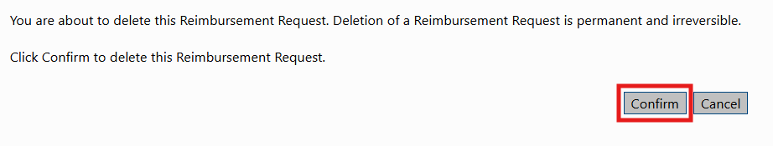

- Previous years’ FERs for the same fund codes (e.g. FC 0310 McKinney-Vento, the ESSA Consolidated application, etc.) must be at FER DESE Fiscal Final Approved status. If you have not submitted the FER for a previous year’s grant, you must do so and it must reach FER DESE Fiscal Final Approved status before you can submit subsequent years’ FERs. If a refund was due to DESE on a previous year’s grant, the refund must be received and recorded in the GEM$ system before subsequent years’ FERs can be submitted. DESE expects that grant returns will taper off given that applicants should not be requesting grant funds until expenditures have occurred.

- Submitting the FER
Start the FER by opening the application and changing the status to FER Started.

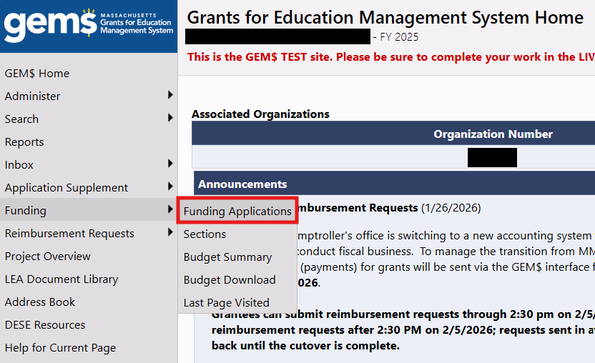
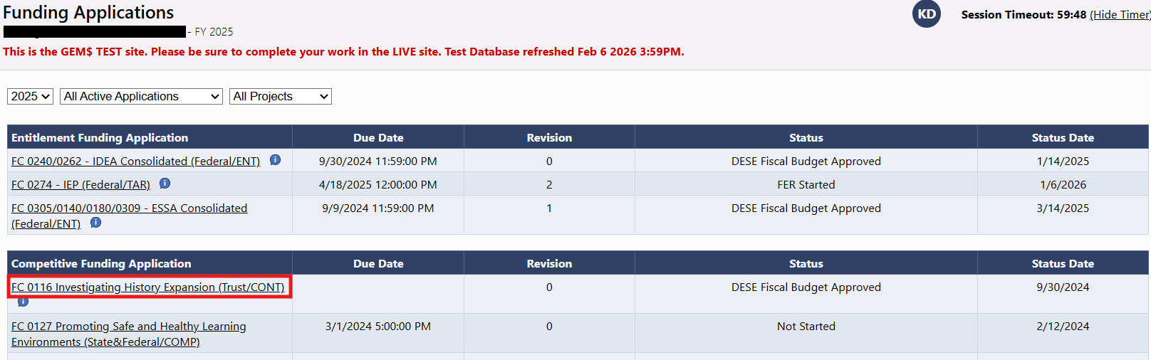
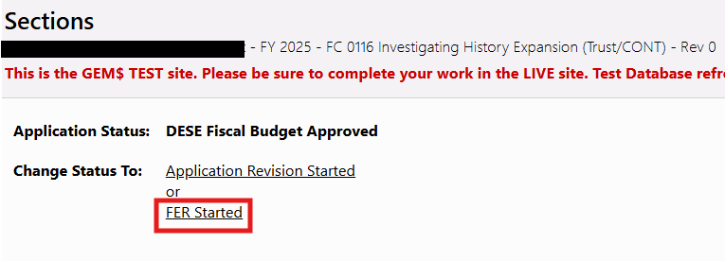
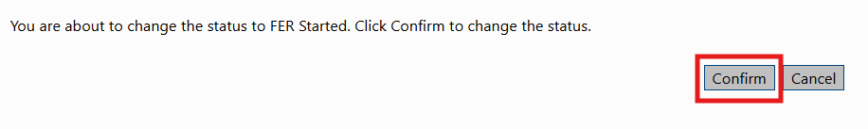

Once the FER has been started, the only editable section of the application is Grant Expenditure Report. For applications comprising multiple grants (e.g. ESSA Consolidated, IDEA), each fund code has its own Grant Expenditure Report. In most cases, this section pulls in the expenditures reported in the last Reimbursement Request and can be edited if your final expenditures differ from what you reported in the Reimbursement Request.
For site-level grants, a Grant Expenditure Report must be completed for each site. These sections do not pull in previously reported expenditures because the Reimbursement Request is not broken down to site-level reporting, so all figures must be entered manually for this type of grant. The total expenditures will automatically roll up to the LEA level Grant Expenditure Report. Select individual sites from the dropdown menu in the Sections view of the FER.
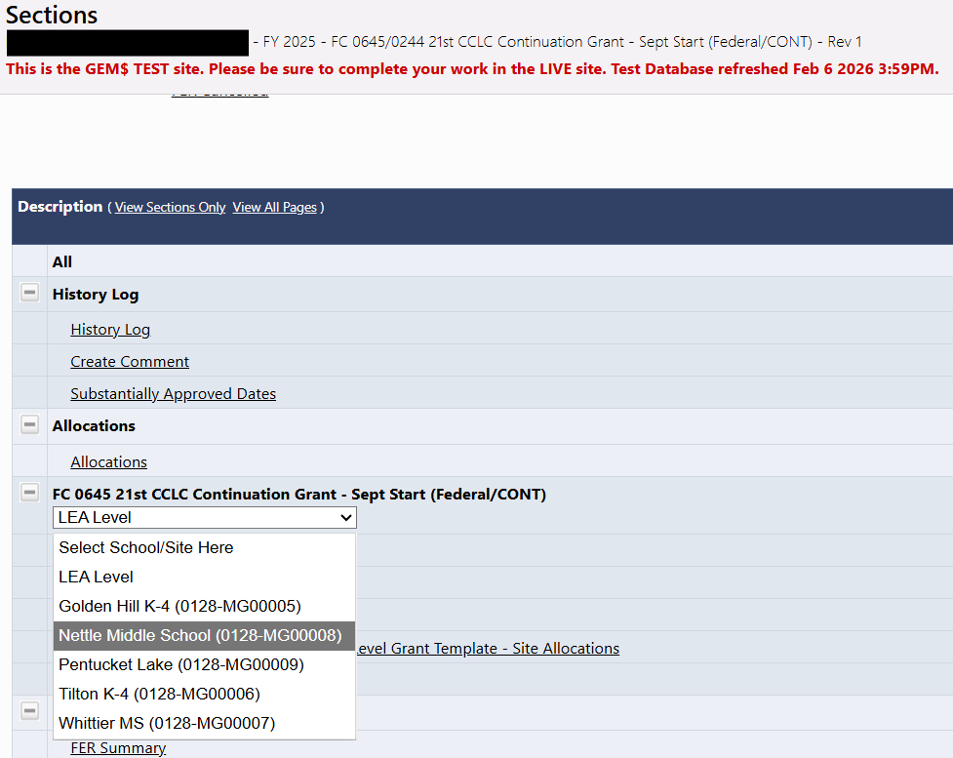

Editable cells are shaded white. Hover over these cells to see the Budgeted Amount, Previous Funds Expended, Total Funds Expended and Amount Remaining for that Object Code/Function Code.
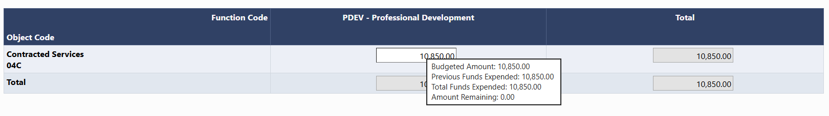
You can report expenditures up to 110% of the budgeted amount, capped at $10,000 over budget. If you report expenditures above this limit you will receive an error message and will not be able to submit the FER. If you cannot reduce expenditures by making an adjustment on your end, you must contact Grants Management at EdGrants@mass.gov or 781-338-6595 and ask us to cancel the FER, at which point you must start a revision to the application to modify your budget. PLEASE NOTE: DESE expects all application revisions to be completed 30 days prior to the end of the period of performance. We understand that unforeseen developments may necessitate late revisions to facilitate the submission of accurate FERs, but we do ask that you review your grant budgets prior to the end of the period of performance to ensure they reflect actual and projected expenditures. Starting revisions at this late stage could result in late filing of the FER or, in some cases, the inability to request remaining balances via the FER.
Once you have confirmed that all the information in the Grant Expenditure Reports is accurate, use the Save And Go To menu to navigate to the FER Summary.
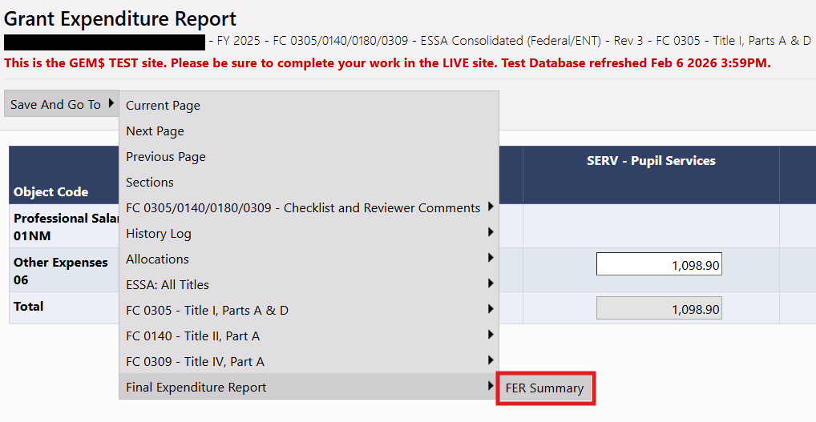

The FER Summary page is a table with columns showing the total allocation, total expenditures reported in the Grant Expenditure Report, total funds received to date, and total amount remaining (i.e., Allocation minus Expenditures) for the component grant(s) of application. The Carryover columns are not applicable to DESE grants.
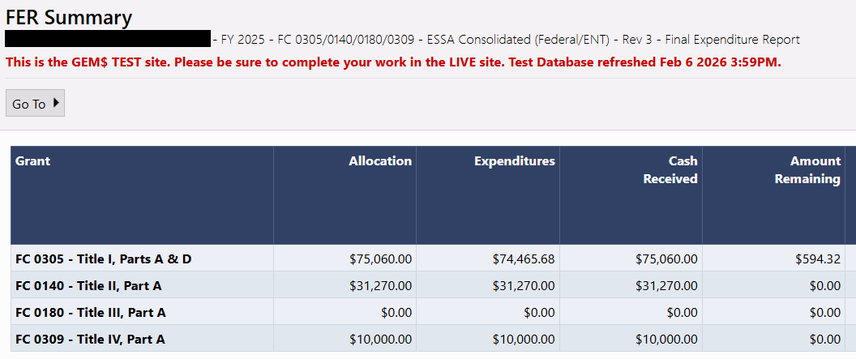
If the figure in the Cash Received column is greater than the corresponding figure in the Expenditures column, you have overdrawn on the grant and owe a refund to DESE. Once an FER with a refund due has been reviewed, it is moved to FER DESE Fiscal Primary Approved status and an email is sent to you with payment instructions. If the refund due is less than $1.00, the amount is considered negligible and you have the option not to pay it back. See Section IV. Negligible Amount Refunds for details.
If the figure in the Expenditures column is greater than the corresponding figure in the Cash Received column, a payment will be generated for the difference upon approval of the FER. The process of using the FER to claim final balances is addressed in detail in the next section.

Once you have verified that the information in the FER summary is accurate, navigate to the Sections page and change the status to FER Submitted.
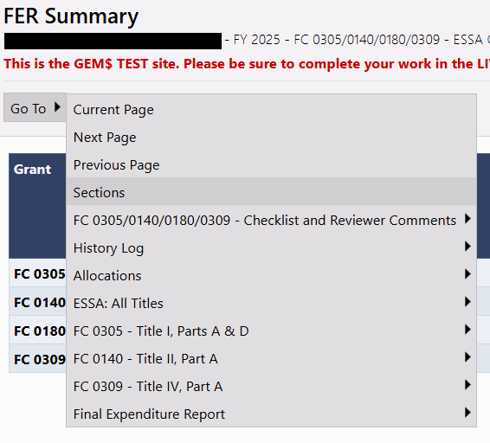
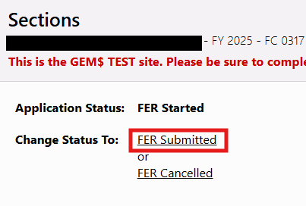

Check the box certifying that the information in the FER is true, complete and accurate and in compliance with the various CFR sections and click Confirm.
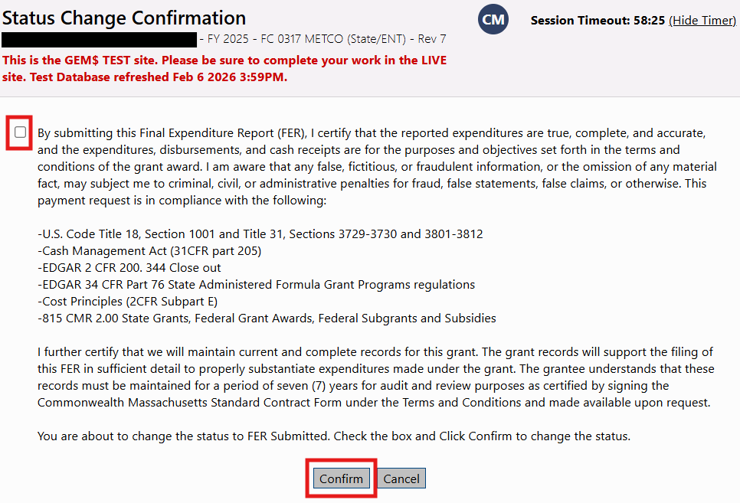

- Using the Final Expenditure Report (FER) to claim final grant balances
Once the grant project duration (period of performance) has passed and grantees are in the liquidation period of the grant cycle, the Final Expenditure Report (FER) can be used to request final balances on the grant. In these cases, grantees are using one form (the FER) to both close the grant and claim final balances.
It is important to note that the timeframe for being able to use the FER filing to collect unclaimed grant balances is finite and must be completed by specific dates to guarantee payment. For example, grants whose project duration ends 6/30 of that given fiscal year must file the FER by 8/15 if it is being used to both claim balances as well as report all final expenditures and close the grant. DESE cannot guarantee payment for FER filings submitted after 8/15 for grants that end 6/30.
Other grant lifecycles would give the full FER filing timeframe to use the filing to both claim final balances as well as close the grant. The grant end date matters and determines what is possible. For example, grants with a 9/30 end date can utilize the full FER filing timeframe (FERs due 12/31) to both report final expenditures as well as claim and remaining balances on the grant. It is always important to know the grant project duration so that the liquidation and closeout parts of the grant cycle can be completed within the proper deadlines. Check the Grant Award Notice to see all important dates on each specific grant.

Fill out the FER and before submitting review the FER Summary Section.
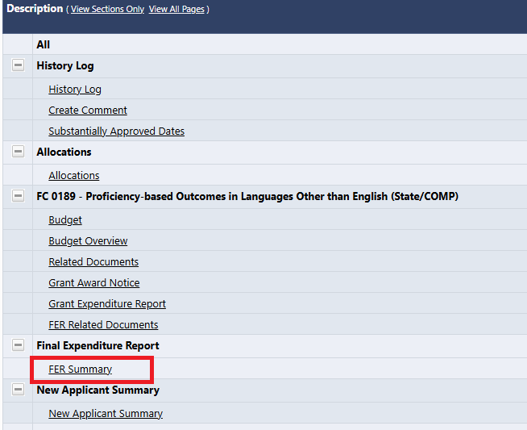
If the figure in the Expenditures column is greater than the figure in the Cash Received column, a Reimbursement Request for the difference will be generated upon approval of the FER.
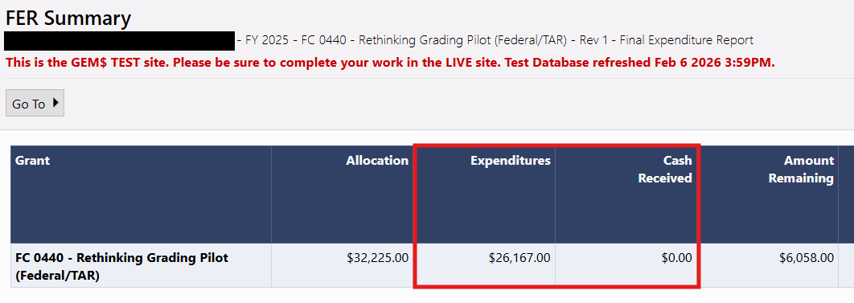
If this looks correct, change status to FER Submitted. Once the FER is submitted, DESE staff will review and a payment approver will approve it. Once you see FER DESE Fiscal Final Approved as the status this means the payment for the amount you saw in Pending Transaction Amount is now in the payment queue for processing. You do NOT need to submit a reimbursement request when you use the FER filing to claim final balances.
FER filing assumes everything is complete, true and correct. If you are not prepared to close the grant because you still have liquidation activities to complete (paying vendors, reconciling actuals, etc.) then it is recommended you request reimbursement using the Reimbursement Request form by the request deadline for that grant to claim final balances. If you miss the final reimbursement request (form) deadline the only option is to utilize the FER filing to claim balances and you must be prepared to close the grant, and all liquidation activities must be completed.

- Negligible Amount Refunds
The GEM$ system expects any amount overdrawn to be returned to DESE, no matter how small. If you owe a refund of less than $1.00, you have the option to mark the owed amount as negligible and DESE will enter a transaction to zero out the balance owed. To request that DESE void the negligible amount owed, create a comment on the FER after it has been submitted that this is your preference.
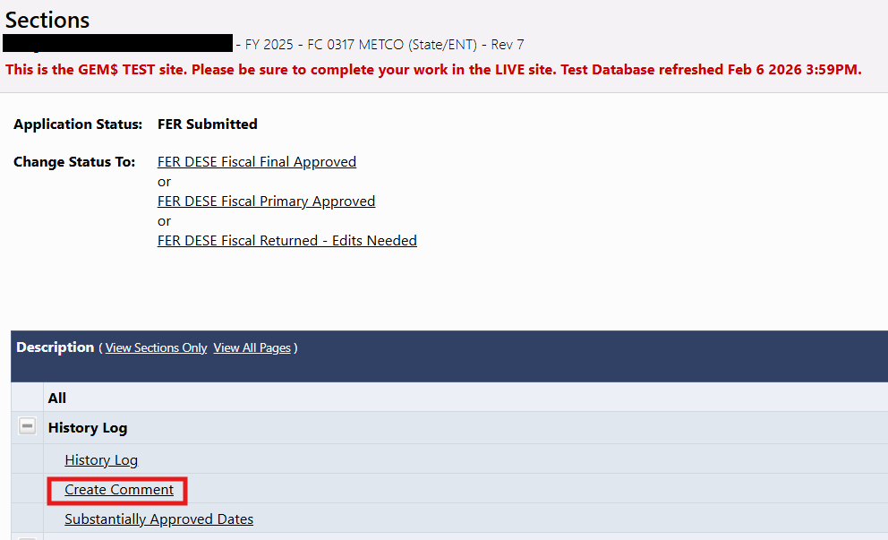
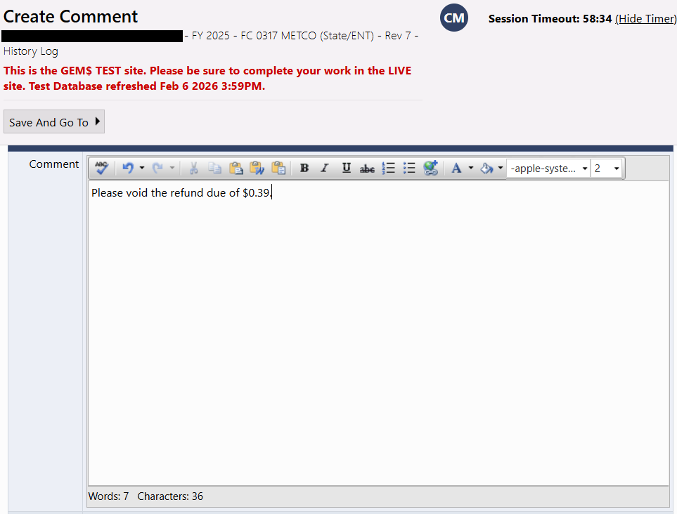

Click Save And Go To: History Log: History Log to confirm that the comment was saved.
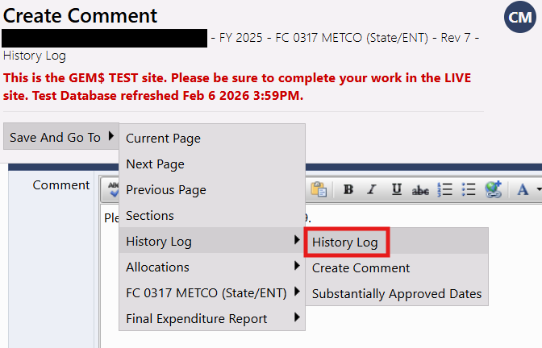
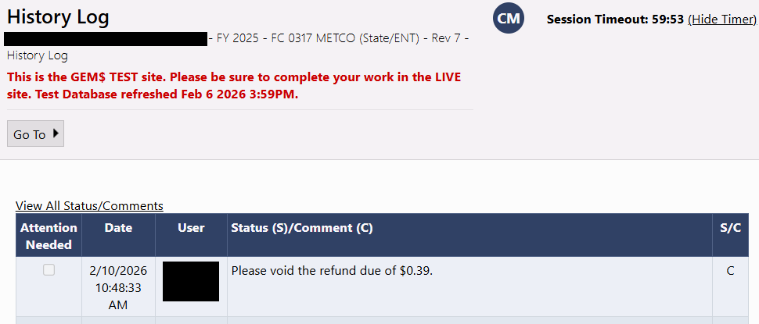
If you do not create a comment asking to void the balance due, DESE will assume that you will send the refund, the FER will be moved to FER DESE Fiscal Primary Approved status and you will receive an email with payment instructions.

- FER Revisions
As previously stated, FER filing assumes everything is complete, true and correct. You formally certify the completeness and accuracy of the FER when you confirm submission of the form. If, however, you realize your reporting is inaccurate after you have submitted the FER, revisions and corrections are possible but should be the exception.
If the FER is at FER Submitted or FER DESE Fiscal Primary Approved status, you can contact Grants Management at EdGrants@mass.gov or 781-338-6595 and ask us to return the FER to you for edits. You can then make revisions and corrections and change the status to FER Submitted to resubmit. If your FER revision requires a budget modification, an application revision to correct your budget is technically possible at this stage, but a firm rationale for a revision at such a late stage must be provided and further discussion may be required before a revision is permitted. In this scenario, contact Grants Management by email describing your reason for needing a budget revision. If deemed reasonable and necessary, we will cancel the FER filing and you can start an application revision. Once the revision has been fully approved, you can resubmit the FER.
If the FER is at FER DESE Fiscal Final Approved status, an FER Revision can be started, but no application revisions/budget modifications can be made at this stage. There are no exceptions to this as the GEM$ system will not allow for application revisions for applications that have reached FER DESE Fiscal Final Approved status. To start an FER Revision, contact Grants Management and we will start the revision for you.

The expectation is that returning FERs for edits and creating FER Revisions should be rare occurrences. By confirming submission of the FER, you are attesting to the accuracy and finality of the report. Please be as certain as you can that the information provided in the FER is indeed final before confirming submission.

