GEM$ Reimbursement Request Process
Grant funds in GEM$ should be requested on a reimbursement basis, meaning expenditures have occurred before you are requesting the funds. “Expended” can mean the expenditures have gone on the warrant and are scheduled to occur; or for organizations that are not school districts, the finance system you use shows that an invoice is paid or a payment is scheduled. This reimbursement model aligns with how the state (DESE) requests and receives federal funding.
If an organization is not requesting grant funds throughout the fiscal year, it indicates to DESE that maybe the grant program is not running and can signal a red flag. Please request funds as they are being spent, at a minimum quarterly, to give DESE visibility that funding is being utilized on its intended purpose.
- Submitting reimbursement requests
Navigate to the Reimbursements Requests screen.
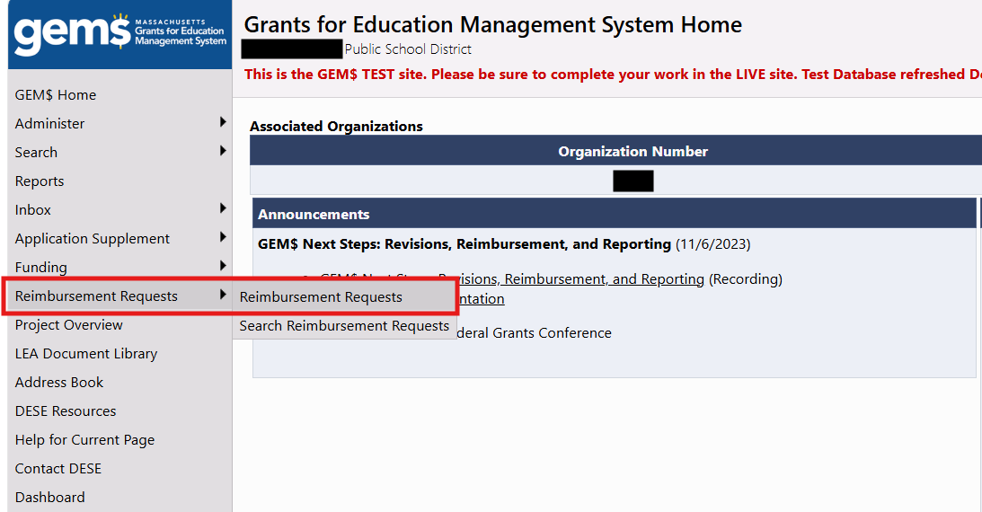

Use the filters at the top of the Reimbursements Requests page to limit results by fiscal year, funding application, and project status (open/closed).
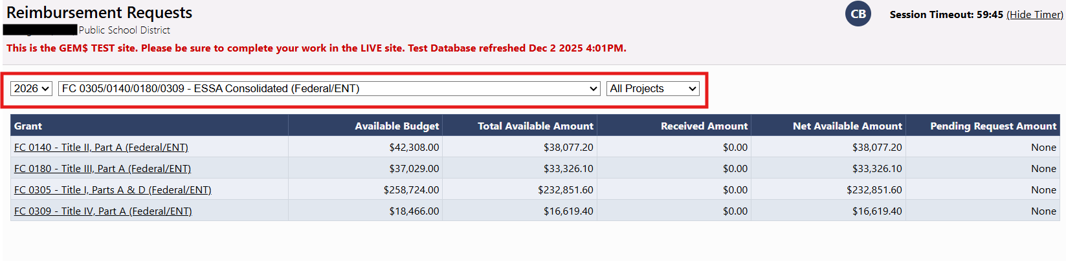
Click on the grant name in the first column to open the Project Summary screen.
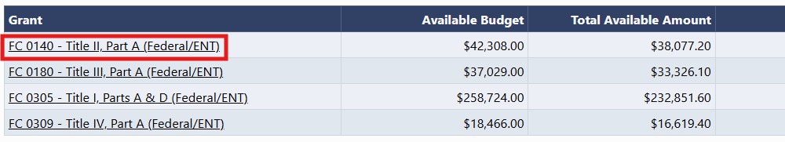

Click the Create New Reimbursement Request link and click the Confirm button to start a reimbursement request.
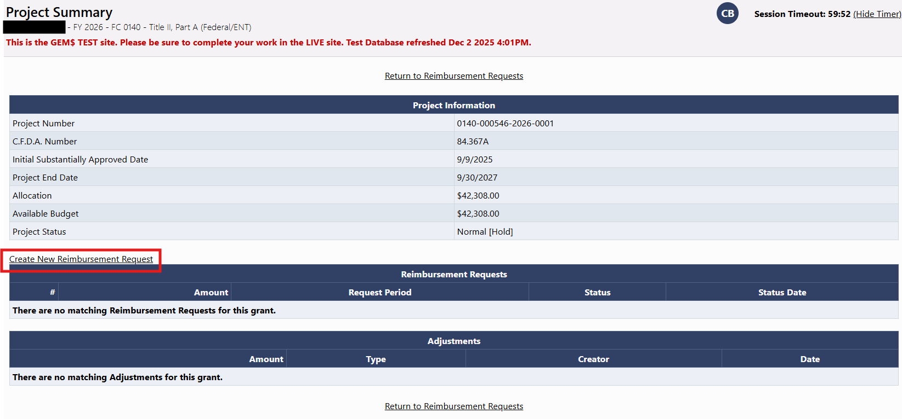

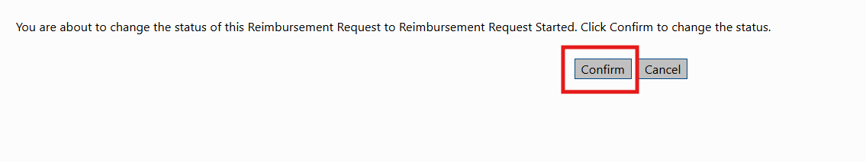

From the Reimbursement Request Sections screen, click on Expenditure Details.
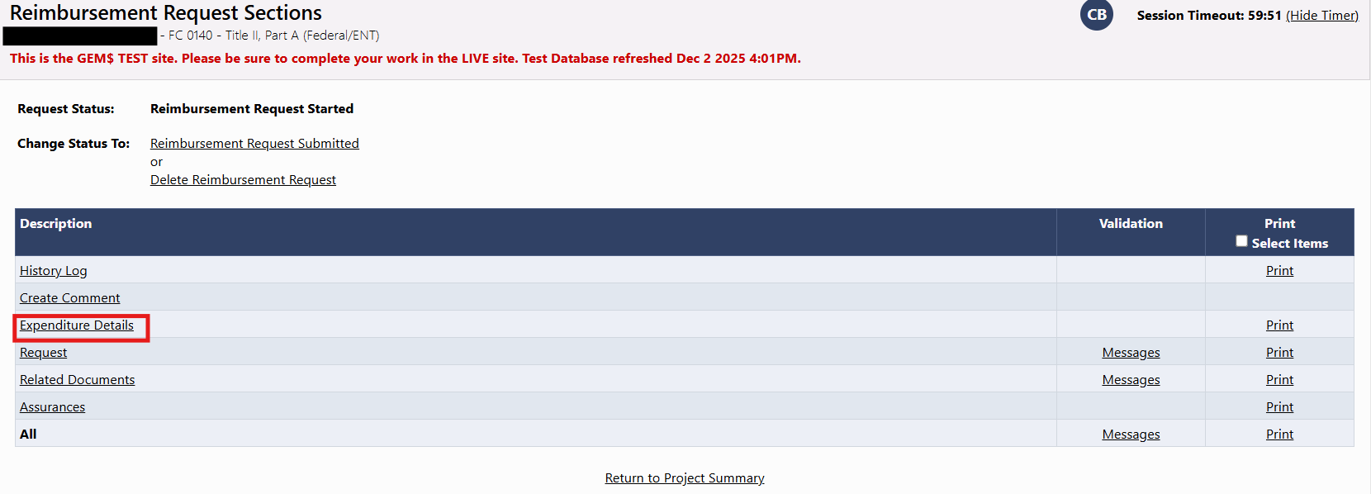
Enter your expenditures in the appropriate field in the Expenditure Details screen. If you have submitted a reimbursement request on this grant previously, this screen will pull in the expenditures reported in the most recent request. Please note: expenditures are reported cumulatively, so report all your expenditures to date in your reimbursement requests, not just expenditures you have made since the last reimbursement request.
Reimbursement Requests list function codes on the left and the Object Codes across the top as pulled from the last approved budget. Hover over the entry fields on this screen to see the Budgeted Amount, Previous Funds Requested, Total Funds Requested and Amount Remaining for that budget category.
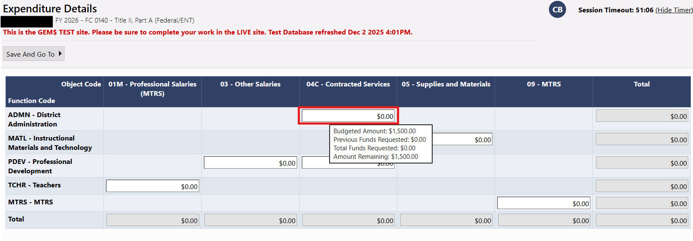

Once you have entered all your expenditures, click Save And Go To -> Sections to return to the Reimbursement Request Sections screen.
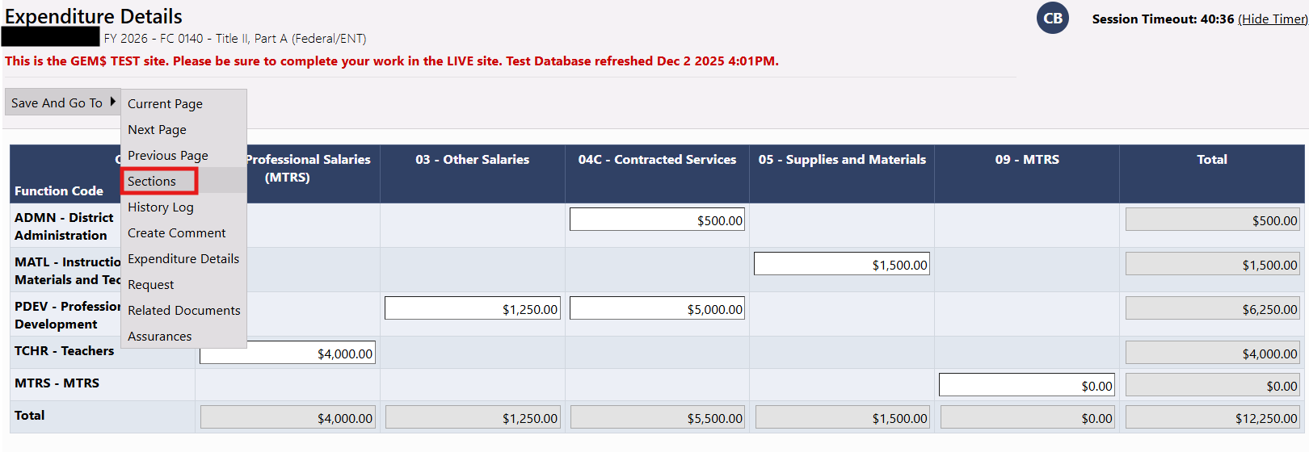

Click on Request.
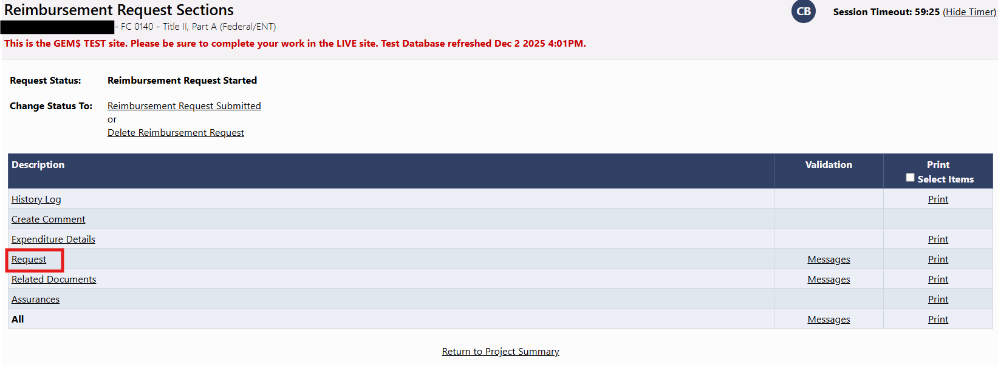

Enter the date of the most recent expenditure reported in the Expenditure Details section on the Fiscal Information As Of line, then click on Save and Go To -> Sections.
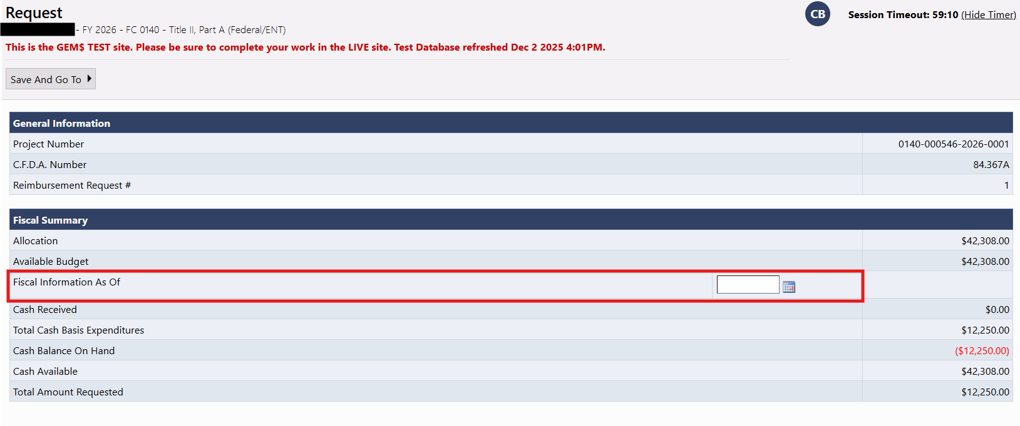
Click on the Messages link on the All line.
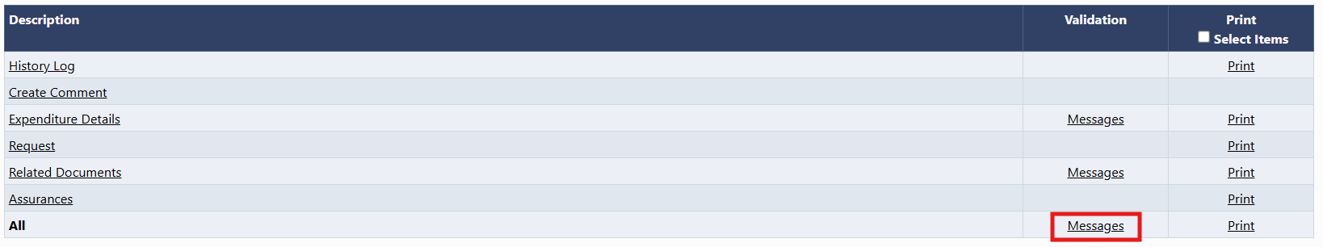

If you see an Error message, you will need to correct something before you will be able to submit the request. Click on the Review link under Actions to navigate to the screen where the correction(s) must be made. Warning messages do not require a correction for the request to be submitted.
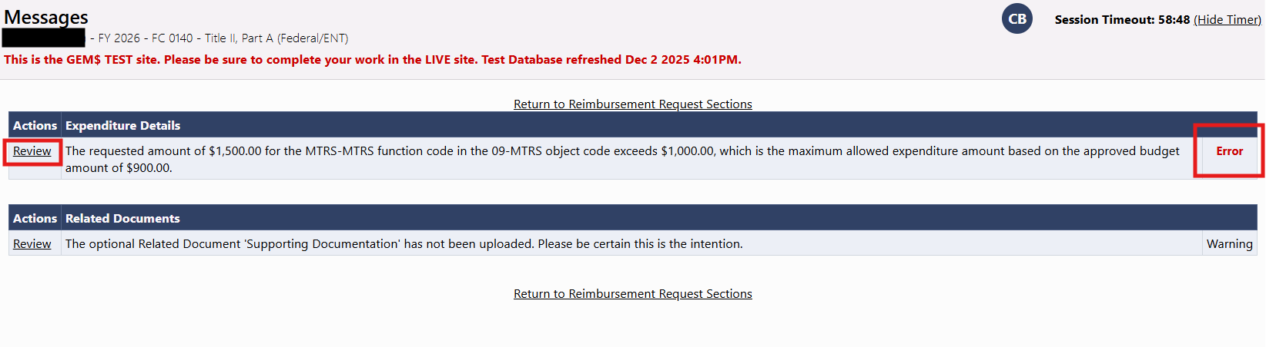
If there are no error messages or you have made all necessary corrections, navigate back to the Sections page to change the status of the request to Reimbursement Request Submitted. The request must be changed to Reimbursement Request Submitted in order for DESE to see the request and process it.
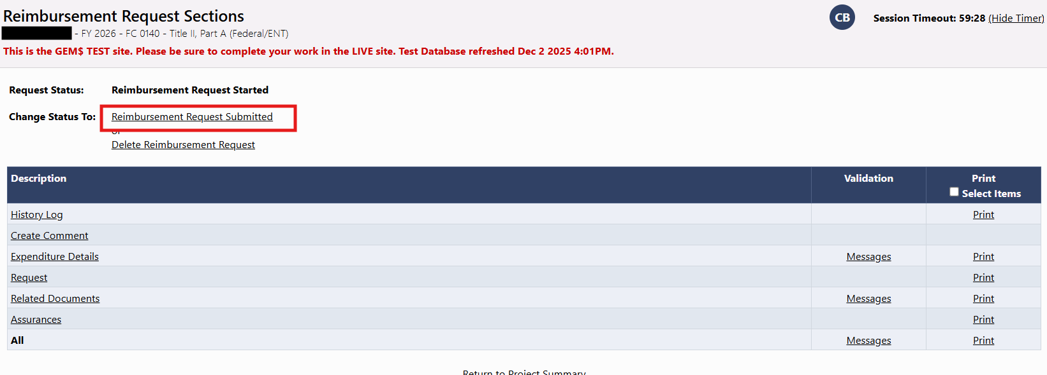

Check the box certifying the accuracy and completeness of your expenditure reporting and click Confirm. The status of the request will then be updated to Reimbursement Request Submitted.
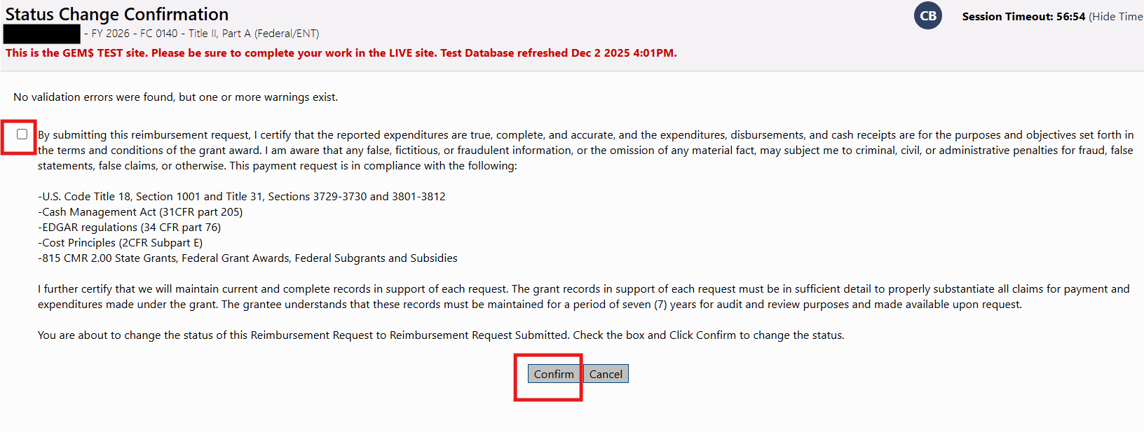

A Note on MTRS
Sometime during the first week of December, DESE makes a payment to MTRS equal to 80% of all grantees’ MTRS budget lines for current fiscal year grants. GEM$ records this transaction as an adjustment to affected grants, which can be found at the bottom of the Project Summary screen.
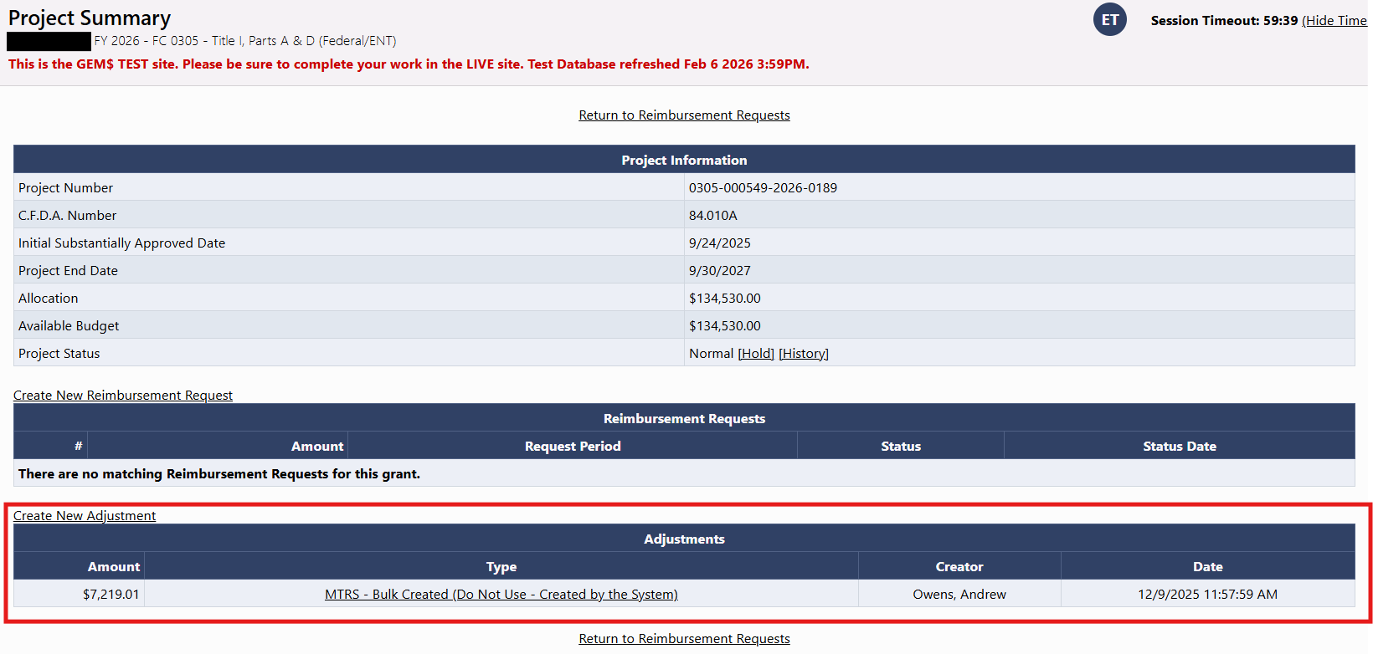
Once this adjustment has been recorded, the payment must be reported as an expenditure on subsequent reimbursement requests. You will not receive these funds as they are paid directly to MTRS, but as it is an expenditure on your awarded funds, it must be reported as such. If you neglect to report the MTRS payment in a reimbursement request, you will receive an error message and will be unable to submit until you correct your expenditure reporting.
We understand that budgets shift, particularly for grants that cross multiple years without a reapplication process, and MTRS salaries and by extension MTRS commitments can increase or decrease throughout the grant lifecycle.
If your MTRS expenses increase, DESE will not send another payment to MTRS and you will owe MTRS the difference between your new calculated commitment (9% of MTRS salaries) and the payment DESE made on your behalf.
If your MTRS budget is reduced to a figure below what DESE has paid to MTRS on your behalf, you will need to report the new lower figure as an expenditure on your reimbursement requests. A refund for the overpayment and a corresponding GEM$ adjustment will be made when you are ready to file your Final Expenditure Report (FER). If you are due a MTRS refund, complete the FER (you will not be able to submit it), then contact Andrew Owens (andrew.c.owens@mass.gov). He will request a refund on your behalf and make a manual adjustment in GEM$ to allow you to submit the FER. Please allow enough time for this process to happen and account for all FER filing deadlines.
- Reimbursement request approval and payment process
Normally, reimbursement requests will be reviewed, approved, and submitted to the state accounting system for payment within three business days of submission, often the same day. It takes approximately seven days for a reimbursement request to go from Submitted to State Accounting System status to State Accounting System Paid status. You may notice that you have received payment on a request that has not yet been marked Paid in GEM$. This is because GEM$ updates reimbursement request statuses based on information sent to the system by the Comptroller’s Office, which may not be provided for a few days after payment has been made.
You cannot submit a reimbursement request for a grant until all previous reimbursement requests have been marked Paid. You can see the status of all current and previous reimbursement requests on the Project Summary screen.
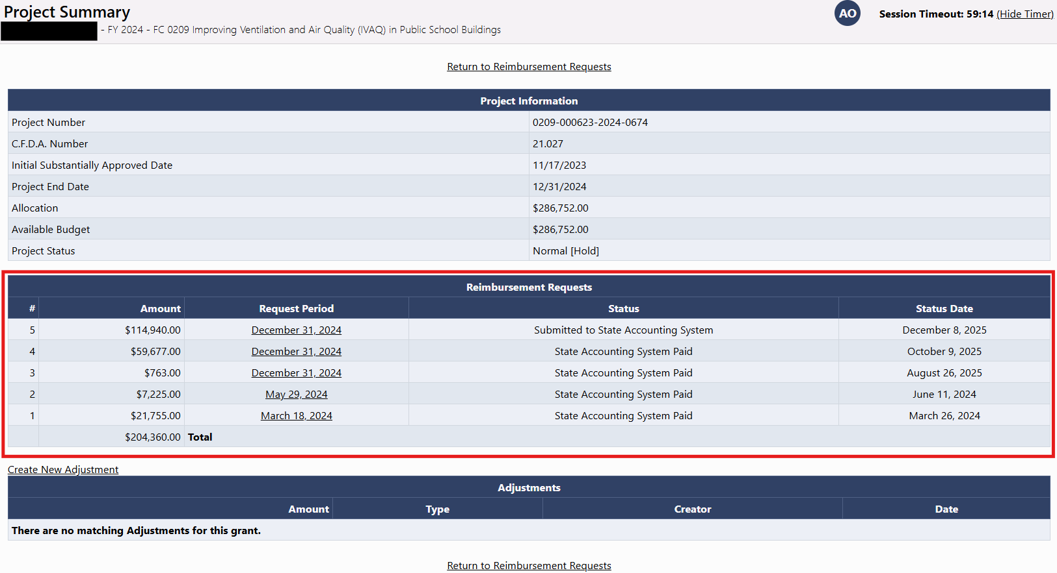
It is uncommon, but a reimbursement request could be returned to you for edits if it cannot be processed. This usually happens when a reimbursement request is submitted while a grant application with a budget modification is in process and the revision is fully approved after the request has been submitted, but before it is approved. If the request reports expenditures on a budget line greater than the allowable amount per the revised budget, it cannot be approved and will be returned to you for edits.
If you realize you have made an error on a reimbursement request, you can ask us to return it to you for edits if the status of the request is Reimbursement Request Submitted or DESE Fiscal Payment Approved. If the request has reached Submitted to State Accounting System status, it cannot be returned and you must wait until it has been paid before you can correct any errors via a subsequent reimbursement request.
Reimbursement requests cannot be submitted if you report total expenditures less than or equal to the amount of funds you have received to date. If you have overdrawn on a grant, you will need to wait until you file the FER to report the discrepancy, at which point you will receive email instruction on how to send a refund to DESE.

- Using the Final Expenditure Report (FER) to claim final grant balances
Once the grant project duration (period of performance) has passed and grantees are in the liquidation period of the grant cycle, the Final Expenditure Report (FER) can be used to request final balances on the grant. In these cases, grantees are using one form (the FER) to both close the grant and claim final balances.
It is important to note that the timeframe for being able to use the FER filing to collect unclaimed grant balances is finite and must be completed by specific dates to guarantee payment. For example, grants whose project duration ends 6/30 of that given fiscal year must file the FER by 8/15 if it is being used to both claim balances as well as report all final expenditures and close the grant. DESE cannot guarantee payment for FER filings submitted after 8/15 for grants that end 6/30.
Other grant lifecycles would give the full FER filing timeframe to use the filing to both claim final balances as well as close the grant. The grant end date matters and determines what is possible. For example, grants with a 9/30 end date can utilize the full FER filing timeframe (FERs due 12/31) to both report final expenditures as well as claim and remaining balances on the grant. It is always important to know the grant project duration so that the liquidation and closeout parts of the grant cycle can be complete within the proper deadlines.

Fill out the FER and before submitting review the FER Summary Section.
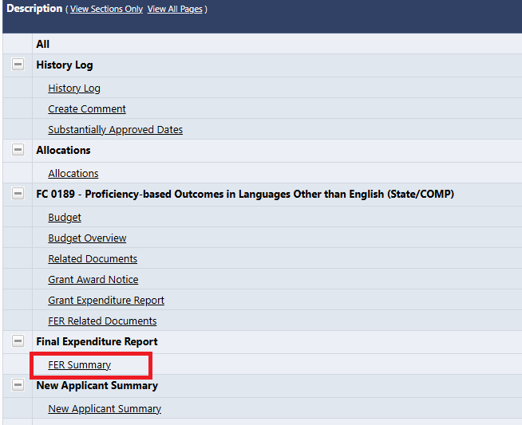
If the figure in the Expenditures column is greater than the figure in the Cash Received column, a Reimbursement Request for the difference will be generated upon approval of the FER.
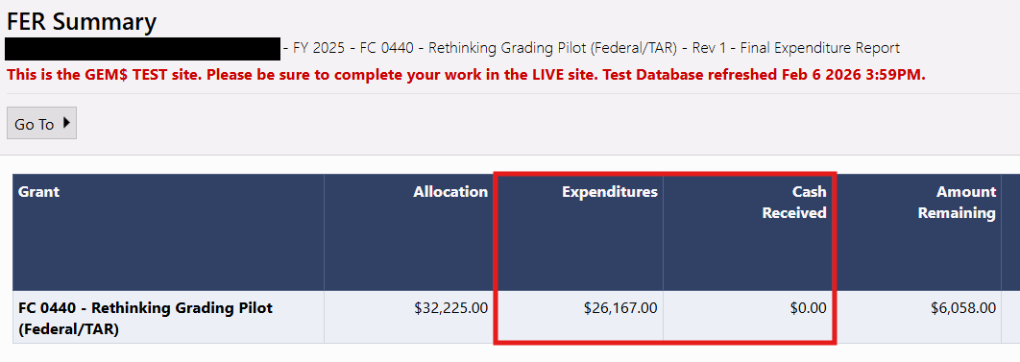
If this looks correct, change status to FER Submitted. Once the FER is submitted, DESE staff will review and a payment approver will approve it. Once you see FER DESE Fiscal Final Approved as the status this means the payment for the amount you saw in Pending Transaction Amount is now in the payment queue for processing. You do NOT need to submit a reimbursement request when you use the FER filing to claim final balances.
FER filing assumes everything is complete, true and correct. If you are not prepared to close the grant because you still have liquidation activities to complete (paying vendors, reconciling actuals, etc.) then it is recommended you request reimbursement using the Reimbursement Request form by the request deadline for that grant to claim final balances. If you miss the final reimbursement request (form) deadline the only option is to utilize the FER filing to claim balances and you must be prepared to close the grant, and all liquidation activities must be completed.

